Venue Hire Guidance

How to Effectively Safeguard Your Premises

Published Sept 2024

**Contents**

What is it? ................................................................................................................ 3

Who is it for? ............................................................................................................ 3

Why use this guidance? ........................................................................................... 5

How to use this guidance.......................................................................................... 6

Premises Protocol Flowchart.................................................................................... 6

Step 1: Scan............................................................................................................. 8

Step 2: Analyse......................................................................................................... 8

Step 3: Respond ...................................................................................................... 8

Step 4: Assess…...................................................................................................... 9

Pre-booking guidance- Basic internet checks......................................................... 10

Managing concerns before and during a booking………………………………….…12

Partnership information: ......................................................................................... 14

**What is it?**

This guidance has been designed to support local venues with their lettings procedures.

Residents who access local venues (council, school, community) have the right to enjoy services and facilities safely and without fear of intimidation, harassment, or threatening behaviour. Without respect for diversity and the differing needs of a community, local venues leave themselves and their service users vulnerable to those who willingly use language and actions influenced by hatred, prejudice, and intolerance towards others.

**Who is it for?**

This booklet has been written to provide practical guidance, and to support the everyday work of local venues and organisations (council, school, community etc.), in promoting community cohesion and giving local people the services they need safely.

It has been designed to assist any individual who has a level of responsibility for overseeing hire and/or use of their premises. Individuals may hold a range of roles in an organisation, including (but not limited to):

* Safeguarding leads
* Booking staff
* Centre managers
* Governing bodies / trustees
* Caretakers

# **Premises Hire and Extremism**

The Prevent Duty requires all relevant staff and responsible adults to undertake proportionate due diligence practices when receiving event or guest speaker requests. It is advisable for settings to implement a policy regarding the vetting and monitoring of guests who are visitors to the venue or provider.

‘Local authority settings should have measures in place to ensure their facilities are not exploited by radicalisers. This includes ensuring that any event spaces, publicly owned venues and resources or IT equipment are not being used to facilitate the spread of extremist narratives which can reasonably be linked to terrorism, such as narratives used to encourage people into participating in or supporting terrorism. Such measures will help to limit access to platforms that can be used to radicalise others.’

*-* [**Prevent Duty Guidance**](https://www.gov.uk/government/publications/prevent-duty-guidance/prevent-duty-guidance-for-england-and-wales-accessible) **in England and Wales HM Government July 2023**

To meet the Government’s definition of extremism, an individual does not have to meet every part of the definition, some of the key areas of concern are:

* *Opposition to democratic government*
* *Intolerance towards other groups, including the protected characteristics*
* *Inciting hatred, violence, or call for the breaking of the law.*
* *Encourage, glorify or promote any acts of terrorism, including individuals, groups or organisations that support such acts*
* *Insulting other faiths, beliefs or groups.*

Settings will need to consider their legal obligations in protecting freedom of speech but balanced with other legal duties such as the Prevent Duty 2023 and the Equality Act 2010. In addition, this sits alongside existing requirements which require venues to secure a balanced treatment of political issues, and that, in educational contexts, pupils are “offered a balanced presentation of opposing views”, including during extra-curricular activities (Education Act 1996).

In order to comply with the Prevent Duty, it is important to ensure that premises in the London Borough of Newham cannot be used by those who promote extremist ideologies that seek to sow division and hatred.

The borough has a duty to be a responsible ‘corporate landlord’ over its estate, ensuring safeguarding of vulnerable people, compliance with regulations pertaining to licensing, health and safety, equality and diversity, and ensuring protections against criminal damage.

This booklet provides guidance on mitigating risk, and examples of processes involved to ensure defendable and informed decisions are made when letting out venues to the public.

The London Borough of Newham recognises the right of people to express their opinions and views, but is equally aware, and committed to ensuring, that such expression does not harm the inclusive dynamic and considerable levels of diversity with regards to race, gender, sexuality, religion/ belief, and age which constitute the basis of our communities. This is key in helping to foster cohesion, tolerance and enable every community to be and to feel safe.

In order to safeguard against harmful division and hatred, the [Prevent Duty Guidance](https://assets.publishing.service.gov.uk/media/65e5a5bd3f69457ff1035fe2/14.258_HO_Prevent+Duty+Guidance_v5d_Final_Web_1_.pdf) when talking about ‘reducing permissive environments’ states:

*‘One way that Prevent seeks to tackle the ideological causes of terrorism is by limiting exposure to radicalising narratives, both online and offline, and to create an environment where radicalising ideologies are challenged and are not permitted to flourish.’*

Care should be taken to ensure that any booking considers the risk that visiting groups or speakers, or the use of technology, could allow for radicalising ideas to flourish. Therefore, if there is perceived risk that violent extremist ideas might be espoused, please contact the local Prevent team for advice-

Community.ResilienceTeam@newham.gov.uk

Venues should also ensure their IT facilities are not used for extremism related searches and research, currently all publically owned IT facilities are covered by the LGFL (London Grid for Learning) filters will report extremist searches. We recommend all private facilities adopt similar filtering systems too.

**Why use this guidance?**

Letting out your premises can be beneficial in providing a variety of services, outreach opportunities, enrichment and support, all of which can be vital in bringing communities together. When hiring premises, it is important that these activities can be delivered and accessed in a consistent and safe manner, and so organisations should be aware of and reduce the likelihood of the following:

* **Safeguarding Risk-** how might this booking pose any form of harm to individuals accessing the venue or organisation?
* **Reputational Risk** – how might an inappropriate booking affect the reputation of the venue or organisation?
* **Media Coverage** – what impact will media coverage of any groups, speakers, incidents or events have on a venue?
* **Operational Risk**- how will the above affect the day-to-day activities and running of your organisation or premises?
* **Legal Implications**– what impact will any form of illegal activity have on a venue, organisation, other users of the venue and local community?

The recommended steps for the booking process are outlined in the flowchart provided on the following pages. It is also important that venues are mindful of the effects of leafleting or other forms of promotion (e.g. stickering, stalls) by extremist groups in and around their premises. If at all possible, such incidents, and any related material, should be sent (communicated) to Newham Prevent Team in the same way this protocol sets out for hall bookings of concern.

**How to use this guidance**

The exemplary protocol uses a four-stage SARA process to ensure that a premises’ hiring process is safe and managed accordingly. These stages are:

* **Scan** – receiving and identifying booking requests.
* **Analyse** – gathering and assessing information and the level of risk posed by the event or provision.
* **Respond** – communicating the process to the applicant, and making a joint decision with partners on whether the event or provision should proceed.
* **Assess** - reviewing the event or provision, and considering future booking requests.

The aim of the protocol is to use this document to safeguard premises, staff, and residents. If a booking enquiry is made that **causes** **concern** (attitude / behaviour/ comments etc.) it is recommended that this booking be passed on to local Prevent Team for further checks.

**Premises Protocol Flowchart**

**Scan**

**Analyse**

**Respond**

**Access**

Supplementary comments for each strand (Scan, Analyse, Respond and Assess - SARA) are given below.

It is anticipated that they will be used in conjunction with the flowchart which follows for each booking.

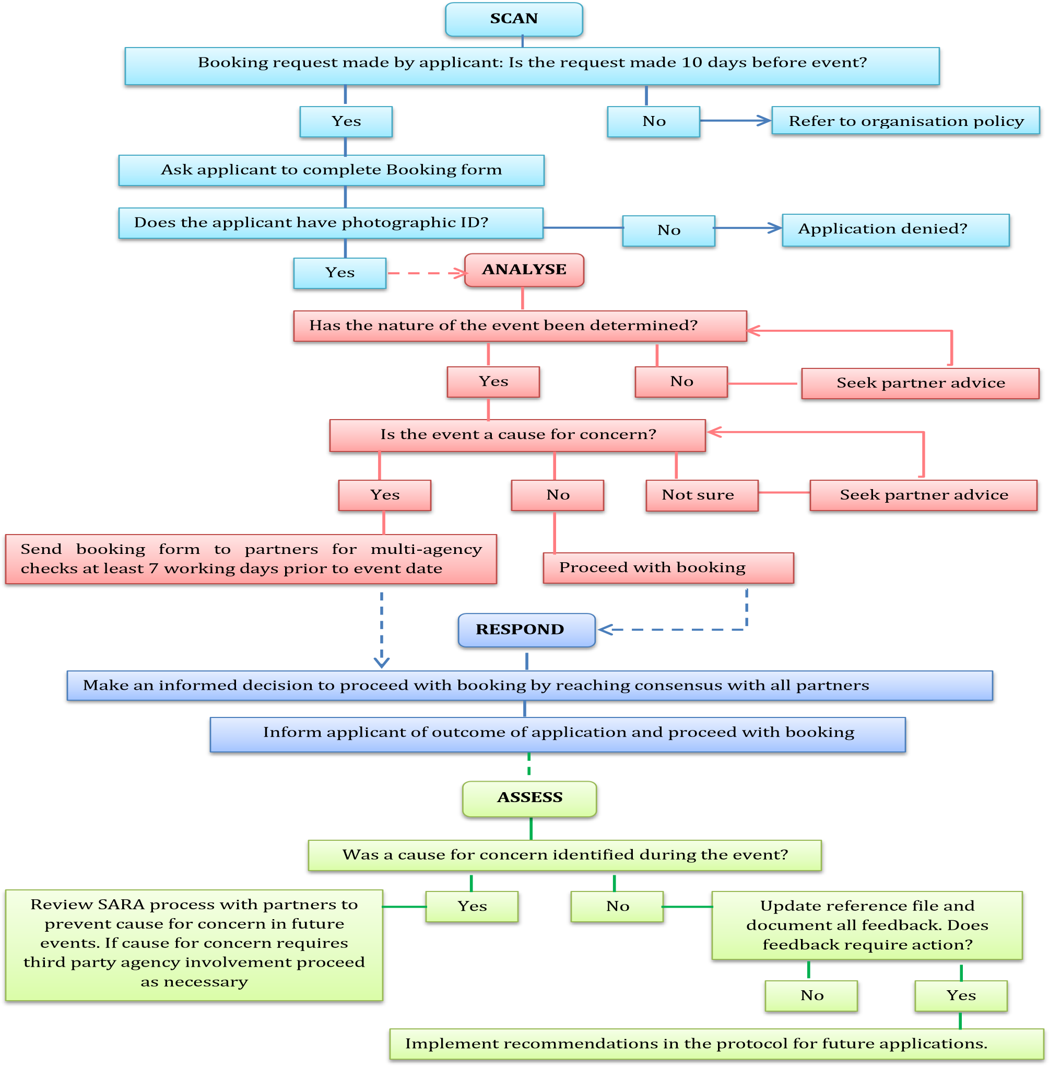

Step 1: Scan

In order for community premises to effectively filter inappropriate guests and/or external speakers, it is recommended that management and booking staff are informed of the requirements to seek permission in advance of any planned event. Venues are advised to ensure they have records that demonstrate that a lawful and proper decision has been taken regarding whether to proceed with a booking or not. For this protocol to be effective, organisations and agencies concerned have an obligation to record information in a way that complies with the rights of individuals concerned, and lawfully achieves the objectives of the protocol. Detailed guidance on information sharing will be provided on request.

Step 2: Analyse

Upon receipt of event notification, the community premises should consider the nature of the event, and assess whether it has any potential to be inflammatory. Guidance on conducting basic internet checks on hiring agencies/individuals/guest speakers is provided in this booklet.

It is recommended that venues should err on the side of caution and, if concerned, notify the Prevent team. This process of notification will allow for considered feedback of an appropriate nature to be supplied to the community premises.

Step 3: Respond

Once research has been conducted and, if required, feedback received from the Prevent team, the organisation or community premises will be in a position to consider all of the information and make an informed decision. It is recommended that the community premises retain the ability to prohibit a speaker from attending if any of the following is satisfied:

**Content:**

The content of the event is likely to undermine Newham’s values of Honesty, Equality, Ambition, Respect and Together.

The content of the event is likely to promote the isolation and/or targeting of individuals or community groups, who would feel discriminated against.

**Guest / external speaker history:**

The speaker has been, or is currently, associated with:

1. Home Office proscribed organisations.
2. Organisations which advocate acts of terrorism, or
3. Any organisation whose beliefs contradict the Community Premises’ Equality and Diversity policy.

The speaker has expressed an opinion/interpretation in public, which:

1. Contradicts the Community Premises’ Equality and Diversity policy in any way.
2. Advocates involvement in violence abroad.
3. Promotes the discrimination against certain community members from others, or is likely to isolate any individual/group of individuals within the community.

**Access**

Step 4: Assess:

The venue is advised to update their reference file. It should detail the outcome of the event monitoring, any adverse or positive feedback, and make justified recommendations for future applications.

## **Pre-booking guidance - Best practice when accepting a booking**

The following are suggestions for ensuring that, once you are happy for a booking to take place, further due diligence is carried out to ensure effective ongoing safeguarding practice:

* Ensure that you are satisfied that the booking and any associated activity will not carry any risks as considered on page 5 of this document. This could include but is not limited to: negligence of safeguarding duties; illegal financial or fundraising activity; incitement or use of hate speech etc.
* Carry out usual DBS checks.
* Carry out basic open-source checks on organisation and key staff, as suggested on page 11 of this document.
* Ensure two staff are allocated to booking processes- note this on any premises hire or other relevant risk assessments you use.
* Carry out soft open source check every 6 months and review bookings annually (including staff turnover for ongoing provisions).
* Brief other staff who may be involved in safeguarding processes related to bookings, such as site maintenance staff, office or front of house staff and IT technicians.

*IF THE EVENT OR PROVISION INVOLVES WORK WITH CHILDREN OR YOUNG PEOPLE AND/OR PROVIDES EDUCATION COURSES OR TRAINING:*

* Quality-assure materials or sessions by requesting example resources, schemes of work, or evaluations of previous delivery.
* Carry out drop-in observations to the provision during facilitation.

*IF USING AN EXTERNAL VENUE HIRE COMPANY TO MANAGE BOOKINGS:*

* Request the hire company’s safeguarding policies and procedures, and evidence of adherence to this, including updates.
* Ensure the hire company notifies your organisation of any new booking requests before accepting or confirming a booking.

## **Pre-booking guidance - Basic internet checks**

When hiring premises, it is advisable to carry out proportionate due diligence on the organisation, group or individual hosting an event or facilitating a provision.

The following are reasonable research steps you may wish to take, using publicly accessible information, to identify those proliferating extremist ideologies and avoid the risk of these individuals or groups unknowingly being given a platform to speak, which could pose risks to your organisation (as listed on page 5). More broadly, these steps may also help organisations to identify those who may pose safeguarding risks relating to other forms of harm and exploitation.

Organisations carrying out internet research on speakers are advised to be mindful of the lack of reliability of some internet material, particularly with regards to social media platforms and forums, and should use sound professional judgement when considering the results of any searches. They should also be conscious of the potential to generate risk through the act of conducting or requesting due diligence checks, hence the use of only publicly-accessible or open-source information checks in these circumstances.

Research should take the form of web searches using a well-recognised internet search engine; the latest Google Chrome application is recommended.

A Boolean search uses certain words (‘connectors’) to allow users to combine keywords to produce more relevant results such as: “extremism”, “terrorism”, “racism”, “sexism”, “homophobia”, “misogyny”, “antisemitism” , “democracy”, and “Islamophobia”.

The search should begin with the person’s name in speech marks, followed by several connectors and key words which should flag-up any extremism concerns, e.g.

“John Smith” AND “extremism” OR “homophobia” OR “antisemitism”

Using alternative spellings of the person’s name, reversing the first and surnames in the search, and adding any distinctive biographical details can also ensure a thorough search is conducted. Organisations are also advised to restrict their online searches to the first 20 hits on any one search engine.

For further helpful guidance on conducting effective internet searches, please see:

[10 Best Web Search Tricks Everyone Should Know](https://www.lifewire.com/web-search-tricks-to-know-4046148)

To ensure compliance with the Regulation of Investigatory Powers Act (2000) and the Data Protection Act (1998), any searches must minimise the risk of unfairly intruding upon on an individual’s right to privacy, and therefore should not include exhaustive trawls of social media content or requesting to follow private accounts associated with the individual.

Where appropriate, venues should ask the hirer to clarify any information of concern raised by the internet search.

However, statutory organisations should not routinely conduct internet searches as described above for the following purposes:

1. Party political events and engagements.
2. Private engagements or meetings held under ‘Chatham House’ rules.
3. Personal or non-official activities or engagements - donating to a charity, for example.
4. Pre-employment checks.
5. Security vetting (they should not be regarded as a form of security vetting or a substitute for Disclosure and Barring Service checks).
6. To identify whether individuals agree or disagree with HMG policy.
7. To identify information that could give rise to reputational risks related to non-extremist behaviour (for instance: financial impropriety).

Statutory organisations should also not routinely conduct internet searches on the following groups:

1. Elected UK officials.
2. UK public servants.
3. Individuals under the age of 18.

## **If concerns become apparent before a booking is agreed**

Please contact the officer responsible for allegations against adults who work with children - LADO (Local Authority Designated Officer) or the Prevent team to seek advice.

LBN LADO: LADO@newham.gov.uk

LBN Prevent Team E-mail: Community.ResilienceTeam@newham.gov.uk

## **If concerns become apparent during the course of a booking- Tensions and disruptions**

Although institutions take many pre-emptive steps to ensure events or provisions take place within the framework of the law, occasionally things do not go to plan and action is required during the course of an event or booking period. Examples include (but are not limited to) attempts to disrupt the event; unexpected attendees, who may present a risk; inappropriate material being made available at the event or provision, or views/behaviours expressed by a speaker, facilitator or audience member falling outside of the law or contrary to Newham’s values (Fellowship, Respect, and Equality and Diversity). In such circumstances, there are a number of options institutions may wish to consider, such as:

* Delaying the start of the event until any tensions or incidents have been resolved and risks mitigated
* Moving the event to a different location
* Issuing clear verbal warnings to individuals attempting to disrupt the event (usually by the event Chair)
* Requesting that individuals leave the event or instructing security (or the police if necessary) to remove them from the event
* Warning individuals that sanctions apply to those impeding freedom of speech within the law
* Postponing the event and rearranging it under different circumstances and conditions
* Stopping the event part-way through
* Cancelling the event

In addition to any of the above, please notify the Prevent Team and inform them of any incident/s. They might deem it necessary to add the individual or group to a list of organisations that Newham should not consider future bookings for, or provide a risk assessment relating to the individual or group.

## **If concerns become apparent during the course of a booking - Safeguarding disclosures**

If an urgent safeguarding concern becomes apparent during the course of a booking you may wish to bring the event or provision to an early finish. In any circumstance where a safeguarding disclosure is made regarding the hiring organisation or an individual involved in the event or provision, you may use the flowchart below to then ascertain the best place to report your concerns. Alternatively, you could contact the Prevent Team to ask for advice and assistance.

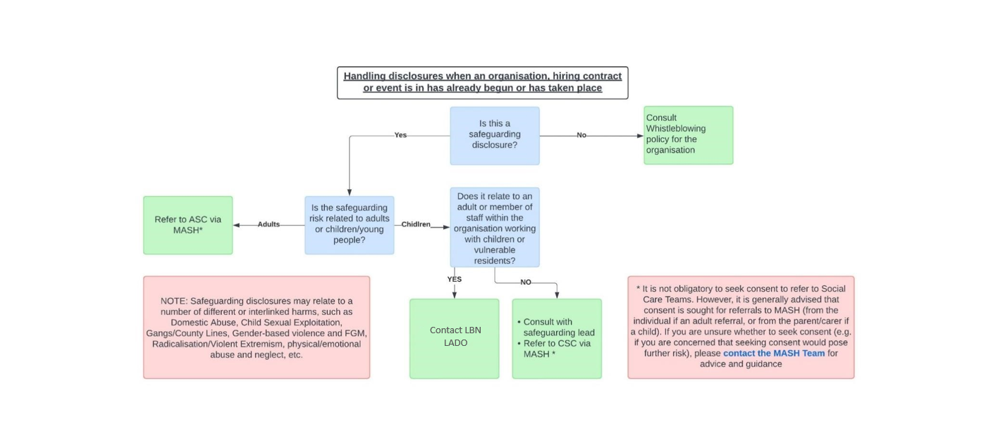

**Partnership information:**

In order to access the relevant partners, and avoid delays in information sharing, it is recommended that organisations seeking safeguarding support with premises hire, guest speakers or events, please contact the LBN Prevent Team.

If requiring specific support relating to premises hire and the risk of extremism, please contact LBN Prevent Team directly.

LBN Community Safety Team E-mail: Commmunity.ResilienceTeam@newham.gov.uk

If there are any concerns raised, the Council will share relevant data with other partner agencies.

If during the course of an event staff become aware of things taking place that could constitute incitement to racial hatred, risk of public order offences being committed, risk of violence and harm to the public they should contact the police in an emergency via making a 999 call.

The non-emergency number for the police is 101.