Newham Council are looking for a resident co-chair for the ASDB meetings.  As Resident Co-chair, you will work with Newham Council and East London Foundation Trust (ELFT) staff to plan and run the Autism Strategy Delivery Board for 12 months.  After 12 months, a new resident co-chair will take over to give others the opportunity. | 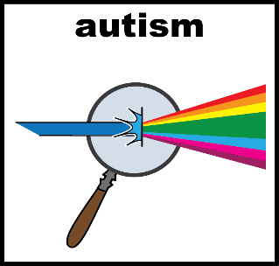
What is a co-chair?  - A co-chair is a person who leads a meeting together with another person.  - You will work with Newham council & ELFT staff.  - Both co-chairs will attend a minimum of 4 meetings a year.  - Each meeting will run no longer than two hours. | 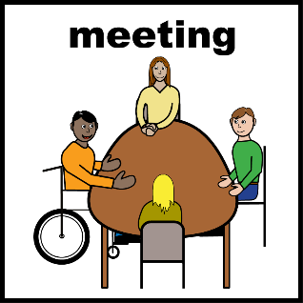
As a resident co-chair you will:  - Help lead the discussion – improve services for autistic community  - Make sure residents voice is heard  - Help the group to make decisions  - Attend other meetings to provide updates  - Read the documents before each meeting  - Work positively to make a change | 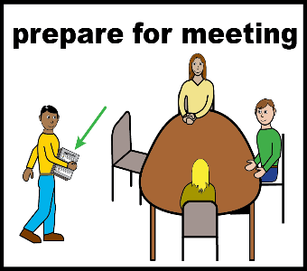
Who can be a co-chair?  - Newham Resident, aged 18+ with an autism diagnosis and  - A member of the Autism Resident Advisory Group (ARAG) and  - Commit to the role for 12 months, must attend the meetings at least every 3 months | 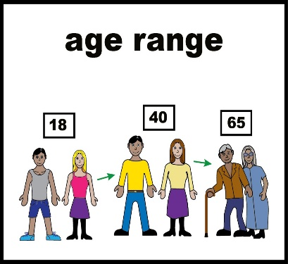
You do not need previous experience. We will support you in the role | 
Who will support the co-chair?  The council will support the resident co-chair by:  - Meeting with you to discuss the Autism Strategy  - Answer any questions you have  - Discuss suitable meeting dates and times  - Support you in preparing for the co-chair role  As a resident co-chair you will also support the ELFT co-chair in preparing for the meetings in advance. | 
Does a co-chair get paid?  Yes. You will receive payment.  - In line with the Council’s Co-Production Reward and Recognition Policy, you will receive a payment of £13.15 an hour (London Living Wage) in exchange for your time  The 6 hours input you provide will cover:  - Up to 1 x hour to review papers and prepare for meetings.  - Up to 3 x hours to attend the meeting itself including travel time.  - Up to 1 x hour follow up / preparation time.  - Up to 1 x hour to meet with the Autism Team as required every three months  You can claim the payment every 3 months (4 times a year) |   
How do I apply?  - Telling us a little about yourself, your experiences, skills and what you can bring to the role  - A maximum of 600 words  - Email us before the deadline at: Autism.Commissioning@newham.gov.uk | 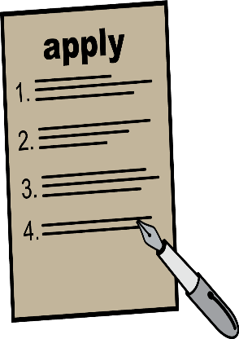
If you need help to do this, please email Autism.Commissioning@newham.gov.uk and we can give you support. | 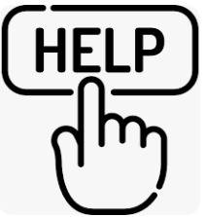
Applications will be shared with the ARAG and, if there are more than two applying for the same role, members will be asked to vote. | 
The deadline to submit your application is Monday 30 September 2024. Applications received after this date will not be considered. | 

