**Here is a quick guide to help you navigate the MiPermit website to apply for Healthy School Street Access Permits**

Once you click the link: [MiPermit Newham Council Cashless Parking and Digital Permits](https://protect-eu.mimecast.com/s/I2hiCZwjrU7gj6lCzcZay?domain=secure.mipermit.com), you should be greeted with the following screen:

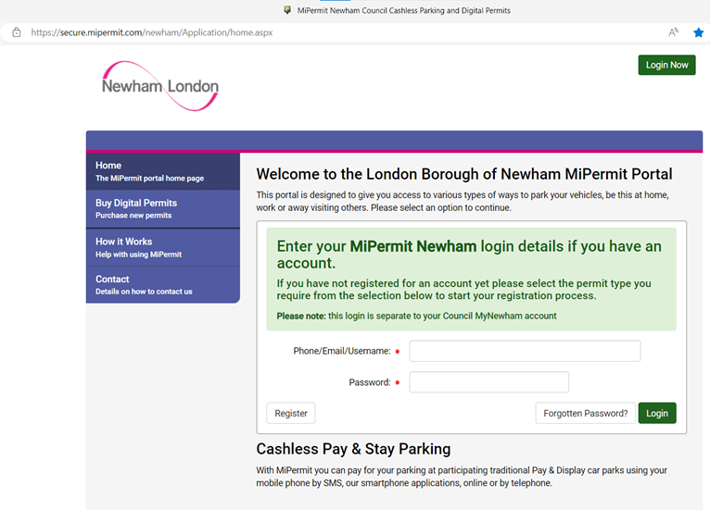

Please select the ‘Buy Digital Permits’ tab on the list on the left. Then you will be taken to the following screen:

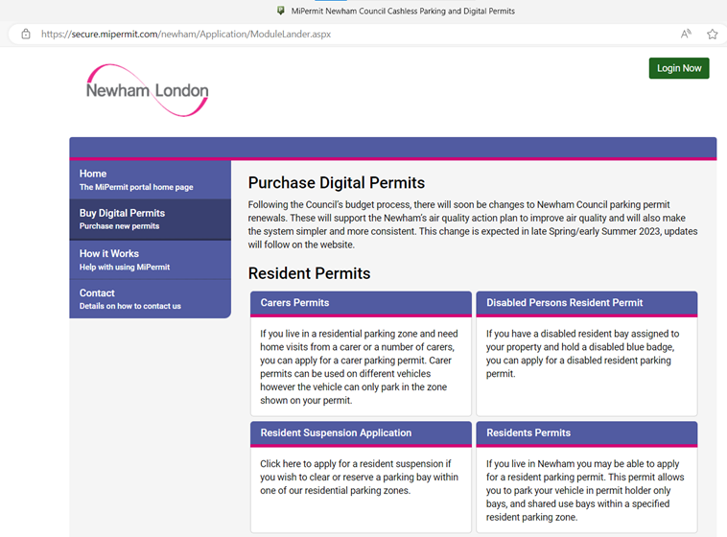

If you scroll down a little bit, you will see ‘Access Restrictions (Browning Road Bridge and Healthy School Streets)’, as shown in the screenshot below.

For Resident exemptions, please select the ‘Access permits’ option, for Business exemptions, please select the ‘Business Access Permits’ option, and for Blue Badge exemptions, please select the ‘Blue Badge Access Permit’ option.

For example, I will go through the process of applying for a Blue Badge exemption.

Please select the ‘Blue Badge Access Permit’.

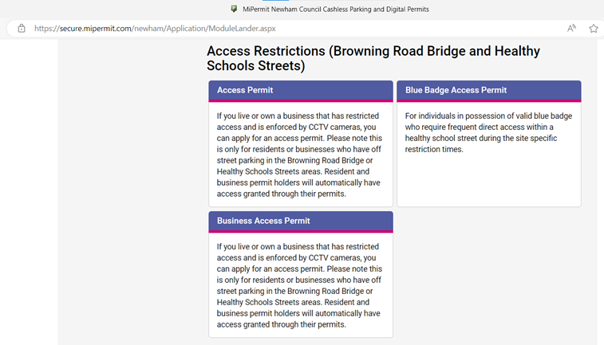

The system should look like this, and enable you to see the following list of schools when you click the drop down menu arrow:

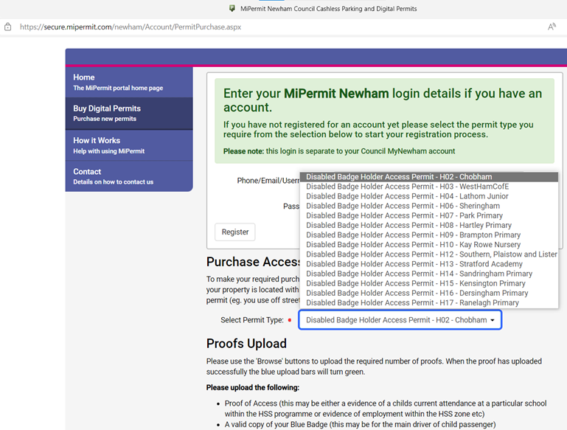

You should then be able to upload all the required documents on this page as well as you scroll down.

If you are don’t see the same on your system, please send us a screenshot that we can pass on to our MiPermit team or you can contact MiPermit directly at [contact@mipermit.com](mailto:contact@mipermit.com).