Focus group Invitation

Housing design for
Residents with Learning Disabilities

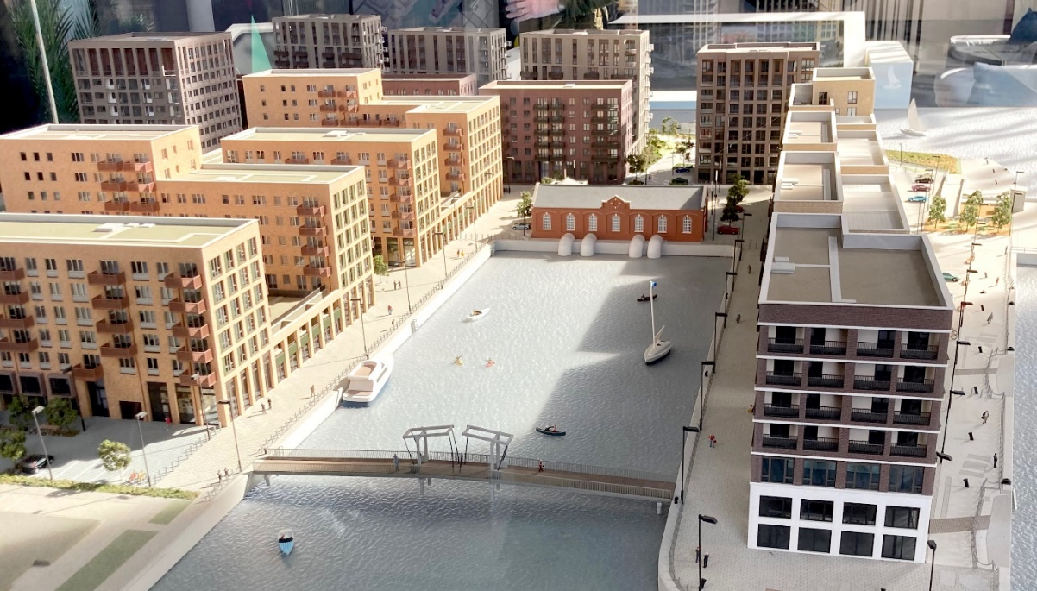

 | Newham’s Planning Policy team would like to hear from you about housing design.
 | They are writing a new policy for new housing developments in Newham.
 | This will tell the building developers about what they need to include in the design of new homes.
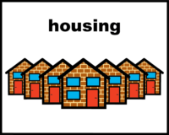 | The Council wants new homes to meet the needs of residents with learning disabilities.  There will be a separate meeting for Neurodivergent residents.
 | The OT Service are helping with the research about what should be in the policy.
 | The Learning Disability focus group will take place Tuesday 18 June.
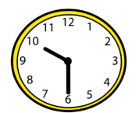 | From 10:30am to 12:30pm.
 | Where: Canning Town Library in the Elizabeth Fry room
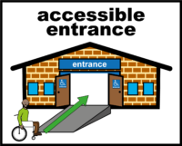 | This meeting will talk about what new housing needs to look like.
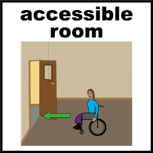 | Tell us what would make new homes and flats better, or what to avoid.
 | Your ideas will help improve the design of new homes in Newham.
£26.30 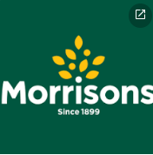 | If you take part, you will receive a voucher worth £26.30 for a local supermarket.
If you would like to attend, please email Claire Laurence.
Claire.Laurence@newham.gov.uk

If you have any questions.

Or if there is anything that would help you participate in the focus group please email Claire.Laurence@newham.gov.uk and we will do our best to accommodate your requirements.
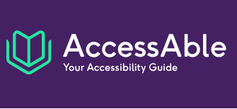 | For more information about the accessibility of the library click here: Canning Town Library.  This will bring your to the AccessAble page. This website.

A privacy notice is attached.

This explains how we will use the data collected during the project. Please read this before attending the focus group.

