Newham Council are looking for a resident co-chairs for the ARAG meetings.  As Resident Co-chair, you will work with Newham Council staff to plan and run the Autism Resident Advisory Group for 12 months.  After 12 months, a new resident co-chair will take over to give others the opportunity. | 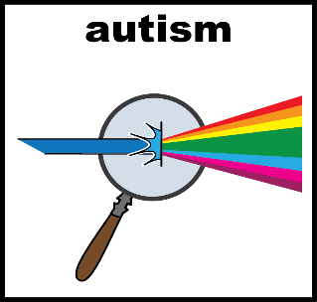
What is a co-chair?  - A co-chair is a person who leads a meeting together with another person.  - You will work with Newham council staff.  - Both co-chairs will attend a minimum of 4 meetings a year.  - Each meeting will run no longer than one and a half hours. | 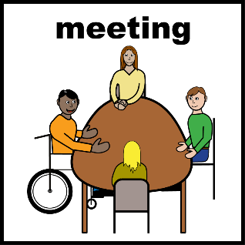
As a resident co-chair you will:  - Help lead the discussion – improve services for autistic community  - Make sure residents voice is heard  - Help the group to make decisions  - Attend other meetings to provide updates  - Read the documents before each meeting  - Work positively to make a change | 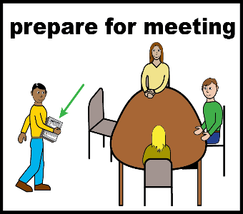
Who can be a co-chair?  - Newham Resident, aged 18+ with an autism diagnosis and  - A member of the Autism Resident Advisory Group and  - Commit to the role for 12 months, must attend the meetings at least every 3 months | 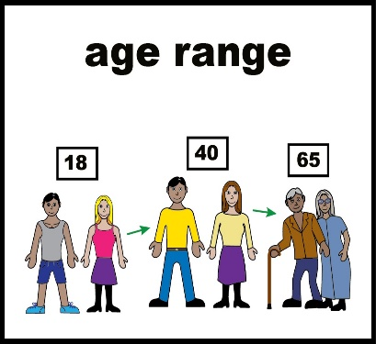
You do not need previous experience. We will support you in the role | 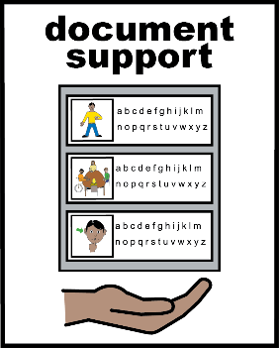
Who will support the co-chair?

The council co-chair will support the resident co-chair by:
- Meeting with you to discuss the Autism Strategy
- Answer any questions you have
- Discuss suitable meeting dates and times
- Support you in preparing for the co-chair role
As a resident co-chair you will also support the council co-chair in preparing for the meetings in advance.
Does a co-chair get paid?

Yes. You will receive payment.

- In line with the Council’s Co-Production Reward and Recognition Policy, you will receive a payment of £11.95 an hour (London Living Wage) in exchange for your time

The 6 hours input you provide will cover:
- Up to 1 x hour to review papers and prepare for meetings.
- Up to 3 x hours to attend the meeting itself including travel time.

- Up to 1 x hour follow up / preparation time.
- Up to 1 x hour to meet with the Autism Team as required every three months
You can claim the payment every 3 months (4 times a year)
How do I apply?  - Telling us a little about yourself, your experiences, skills and what you can bring to the role  - A maximum of 600 words  - Email us before the deadline at: Autism.Commissioning@newham.gov.uk  If you need help to do this, please email Autism.Commissioning@newham.gov.uk and we can give you support.  Applications will be shared with the ARAG and, if there are more than two applying for the same role, members will be asked to vote.  The deadline to submit your application is Sunday 30 June 2024. Applications received after this date will not be considered. | 