School admission appeals for Year-7 places in secondary schools
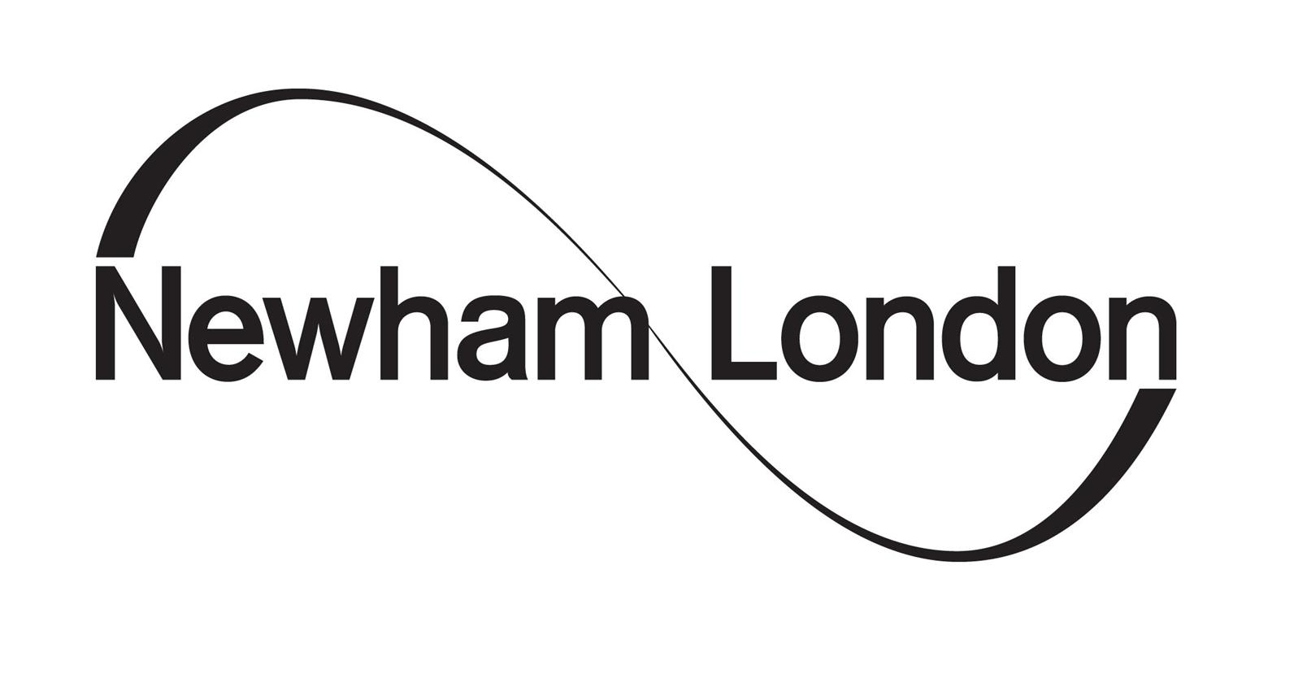
Planned dates for 2024 Entry

Deadline to submit Appeal forms - Friday 29 March 2024
Important information
Extra Information
If you would like the Appeal Panel to see any extra information after you have submitted your appeal form, you must email the Appeals’ Clerk, at least three days before the date of your hearing. Anything submitted after this date may not be admitted or your hearing may be moved to a different date.
Email: Nisas@newham.gov.uk
Appeal Decisions
At your appeal hearing, the Appeals’ Clerk will tell you when you will receive the decision about your appeal.
The Appeals’ Clerk will always try to send the appeal panel’s decision letters a week after the last hearing for the school you are appealing for.
For example, if your appeal was on the first day of Brampton Manor Academy appeals (13 May), the Panel cannot make any decisions until they have heard all the appeals for that school (28 May). Therefore, you will be given your outcome a week after the last appeal has been heard.
School Name | Planned Appeal Hearing Dates | Date when Appeal Hearing details are emailed to parents/carers
Information published on 1 March 2024 and dates below may change.
Please check our website regularly for any updates.
Bobby Moore Academy | 17 June 2024 | 3 June 2024
Brampton Manor Academy | 13 to 24 May 2024 | 29 April to 9 May 2024
Forest Gate Community School | 29 April to 1 May 2024 | 14 April to 16 April 2024
Kingsford Community School | 10 June 2024 | 20 May 2024
Langdon Academy | 12 June 2024 | 22 May 2024
Lister Community School | 10 June 2024 | 20 May 2024
Little Ilford School | 7 to 8 May 2024 | 22 to 23 April 2024
Oasis Academy Silvertown | 5 June 2024 | 15 May 2024
Plashet School | 3 June 2024 | 13 May 2024
Royal Docks Academy | 10 June 2024 | 20 May 2024
St Angela’s Ursuline School | 6 June 2024 | 16 May 2024
St Bonaventure’s RC School | 10 June 2024 | 20 May 2024
Sarah Bonnell School | 6 June 2024 | 16 May 2024
School 21 | 14 June 2024 | 24 May 2024
Stratford School Academy | 9 to 10 May 2024 | 24 to 25 April 2024
Dates for other Newham schools will be listed at a later date.

Harris Academy Chobham | Please check the school’s website for details about their appeals process.

Schools outside Newham | Please contact the school or local authority direct about their appeals process.

