Learning Disability Action Plan
Delivery Board Minutes

Friday 17th November 2023, 10:30am - 12:00pm

People at the meeting:  Jade Sempare  Christopher Fuller  Melissa McAuliffe  Nathan Paul  Sonya Thomas  Patricia Moody  Angie Ingleton  Joseph Kunyeda  Ross Gerrie  Latifat Honey Sarfo  Hannah Leask | Role/ Organisation  Co-Chair  Co-Chair  Co-Chair for Helen Murphy. Commissioner (Adults)  Resident Representative  Personal Assistant to Jade  VoiceAbility Connections  Social Work Service Manager Newham Council  Our Newham Works Manager Newham Council  Commissioner (Children and Young People) Newham Council  Co-Production Officer Newham Council  Senior Commissioner (Adults) Newham Council
Apologies  Lee Salmon  Patricia Handley  Simon Bedeau  Robin Betts  Helen Murphy  Mohammed Arfan  Claire Greszczuk  Karl Henson  Marc Jackson  Gary Woolvett | Provider Representative (Inclusive Care and Support)  Barts Health  Hospital Learning Disability Nurse  East London NHS Foundation Trust  People Participation Lead  Community Learning Disability Team Manager  Newham Council  Senior Commissioner and Co-Chair,  Workforce Development (Training)  Public Health Assistant Director  Assistant Director Commissioning  In-House Day Opportunities Manager  North East London Integrated Care Board, Senior

 |  | What we talked about and Actions
 | 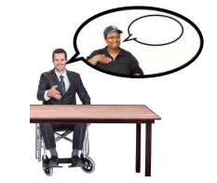 | Welcome and introductions/apologies  Melissa welcomed attendees and noted apologies.  Melissa said that the Resident Advisory Group had elections for this year’s Co-Chairs.  Jade and Christopher will share the Delivery Board Co-Chair role.  Nathan will be the Resident Advisory Group Co-Chair.  Attendees introduced themselves.
 | 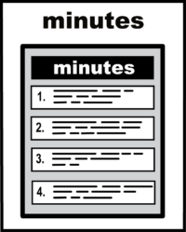 | Minutes and Actions  The Chair cancelled the last Delivery Board due to poor attendance.  This meant that there were no minutes or actions to review.
 | 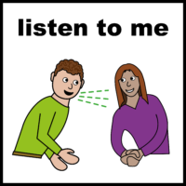  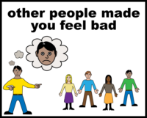  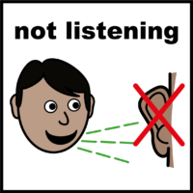  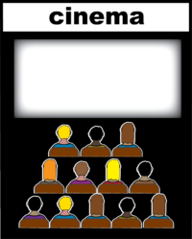  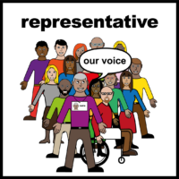 | Feedback:  Learning Disability Resident Advisory Group, Co-production, People Participation  Nathan gave feedback from the last Resident Advisory Group. Here is a summary.  10 residents attended the meeting.  The theme for the meeting was Being heard and valued  - Residents said it was important to be treated with dignity and respect  - People thought that leisure centres and clubs are respectful when there are disability-specific groups.  - There are places in the community where people felt discriminated. This included shops, restaurants and public places.  - There was an example someone who stopped going to Stratford Picture House.  Action 1: Joseph said that he would talk to Stratford Picture House cinema and offer Disability Awareness training.  Joseph to update the group at the next meeting.  - Residents felt that Providers, the Police, the Council, Support Workers and even some Social Workers and Advocates have a lack of respect and understanding.  - They felt that people do not take the time to listen and are dismissive. There is no respect for people with Learning Disabilities  - Residents said that people who do not listen think they know better than the person with Learning Disabilities does.  - 7 people said they are shown respect in the community.  - They want accessible information. The group likes easy read and audio. The group voted which easy read images they prefer  Other Co-Production feedback:  Honey had problems with the meeting link, so could not join for this part of the meeting.  Simon could not attend this meeting.  Action 2: We will try to have feedback from Co-production and East London Foundation Trust at this Delivery Board.  Action 3: We need a Carers Representative for this Delivery Board.  There is a job outline for the Carers Representative. Commissioners will share it with the Carers Resident Advisory Group.  Action 4: We need a Provider Representative from Adults and Health Social Care providers.
 | 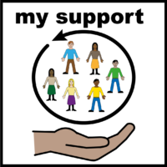  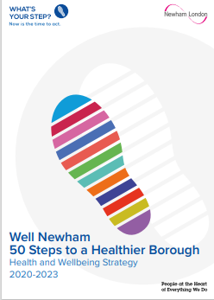  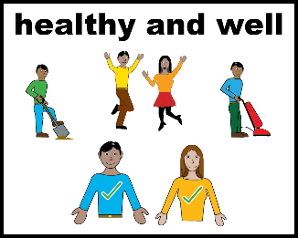  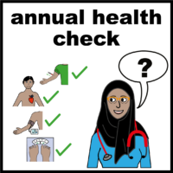  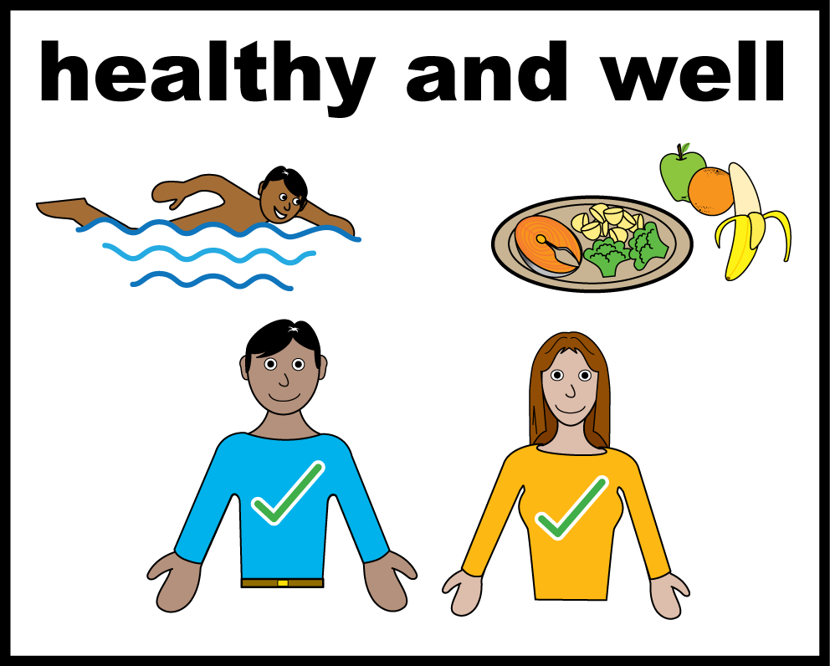  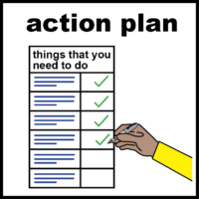  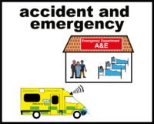  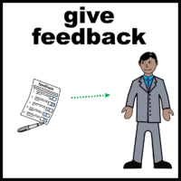 | Learning Disability and Autism Joint Planning Group  Melissa went through the update that Helen Murphy prepared.  Please see the slides.  - Some work has to be done before a new Peer Support Worker job can be advertised.  - This will be a job for either someone with a Learning Disability and/or Autism.  - There have been a couple of meetings to discuss keeping better information about residents with Learning Disabilities  - The information that you collect can also be called data.  - Newham Council and Health disability labels in our computer records. This helps us to look for patterns.  - For example, we can see how many people with a Learning Disability use services; and can check if some groups are not using services.  - Right now different services use different labels for Learning Disability. We want Health and Social Care to use the same labels so we can be clear about who is getting support.  - The Joint Planning Group are looking at linking the Learning Disabilities Action Plan and 50 Steps to a Healthier Borough update.  - 50 Steps to a Healthier Newham is a Health and Social Care plan for Newham.  - It looks at ways to keep all residents healthy and active.  - This include how we can have a healthier life, being a part of your community, and feeling good about how your life is going so that you don’t need mental health services later in life.  - The Joint Planning Group has a goal to keeping people out of hospital and having better support in Newham.  - There is a lot of work happening between Health and Social Care to make sure people can avoid hospital admissions for both physical and mental health.  - Angie said that not everybody is having Annual Health Checks.  - GPs should offer Annual Health Checks to all their patients over 14 years old who have a Learning Disability.  - Angie thinks that many people are also missing having a Health Action Plan and a Hospital passport.  - Angie knows about a few people have been admitted into hospital recently. One person spent a week in the Accident and Emergency department waiting for a Mental Health bed.  - We need to talk to Health colleagues, such as Learning Disability Nurses in Bart’s Health and our local hospital about how we can improve the journey for people going into hospital.  - We need to talk to GP’s to make sure that Annual health checks are booked in, hospital passports and health action plans.  Action 5-7: Melissa will feedback to health colleagues of the delivery board.  Melissa will ask for feedback from:  - Action 5 Tricia Handley about the Hospital Support  - Action 6 Robin Betts – about the work that the Learning Disabilities team are doing to support about people getting the right health checks  - Action 7 Gary Woolvett from the Integrated Care Board because they work with GPs.  - It would be useful to look at the data and compare the number of health checks taken place over the last few years.
 | 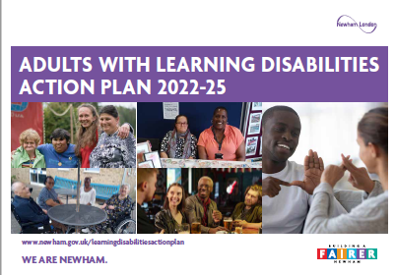  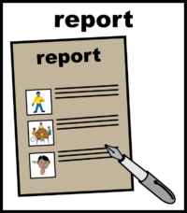 | You Said, Together We Did  This is a report to say what has been done to meet the goals in the Learning Disability Action Plan.  Melissa said that  - A plain English Update Report was presented to the Resident Advisory Group in the summer. Paper copies were shared at the last Resident Advisory Group in September.  - The Joint Planning Group were asked read the full Report. They then agreed that it was ready to publish.  - The action plan is currently with Newham’s design team.  - Some the Delivery Board members are working on the actions.  - Melissa said thank you to everyone who helped write the report. She will share the final version and add it to the Newham website soon.  - We will also have an Easy Read version on the website  - the Resident Advisory Group minutes will have an audio version as well as easy read.  Action 8: Newham to update their webpages with the You Said, Together We Did Update Report.
 | 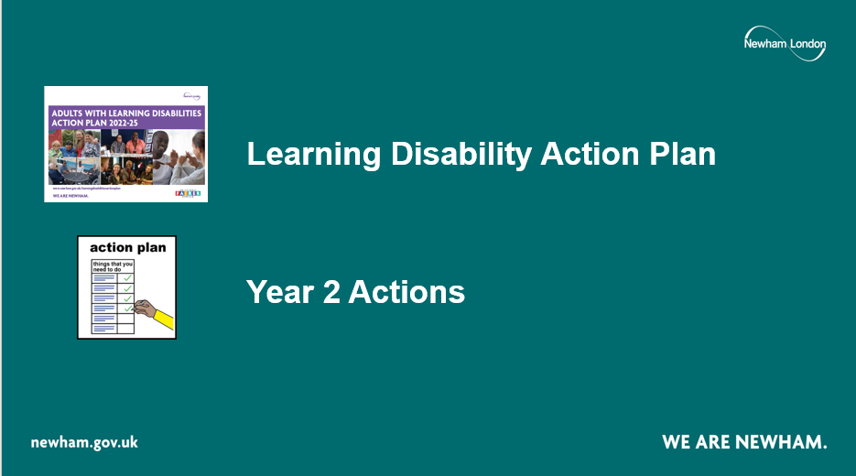 | Action Plan Year 2 Actions  Melissa went through a Slide pack with an update.  There are many actions for this year.  Please read the Slides.
 | 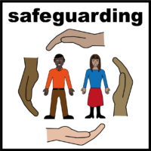  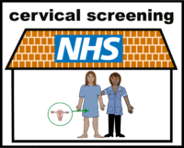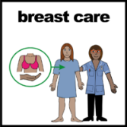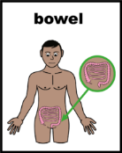  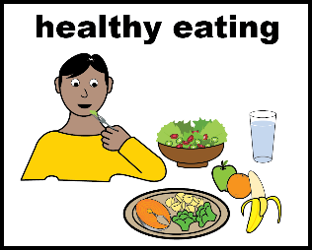 | Any Other Business  - Safeguarding Awareness week is next week – Angie sent through the details in the chat.  - Melissa helped one of the Co-Chairs register for this after the meeting  - Ross said that there was an event yesterday for people who had not replied to Oncology screening.  (Oncology screening is the same as Cancer Screening)  - There was information at the event about breast screening, cervical and bowel cancer.  - There was information looking at other aspects such as nutrition and healthy eating programme. Ross to share the links with the group and if needed to include colleagues from NHC which is the new healthcare collaborative and make some connections.  - Honey’s Team is organising a Celebration for International day for people with disabilities.  - The event will be held on Monday 4th December at St Marks Community Centre between 11am to 2pm.  - There will be stories and inspirational speakers, highlighting the social model of disability. There will be some entertainment and the headlining act is ‘Act up Newham’.  - There is a small grants programme for carers, as part of the Carers Strategy.  - One of the bids was to develop a new peer support group.  - This will fund peer support older residents who are caring for people with learning disabilities in the community.
 | 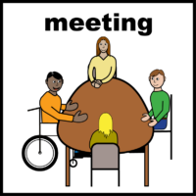 | Date of next meeting:  Friday 2 February 2024  10:30am – 12:00pm  This will be at Newham Dockside and on Microsoft Teams.

