Newham Learning Disability
Resident Advisory Group 18 September 2023

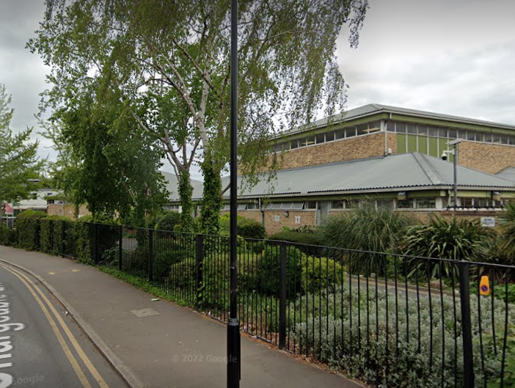 | The meeting took place at Chargeable Lane Resource Centre.
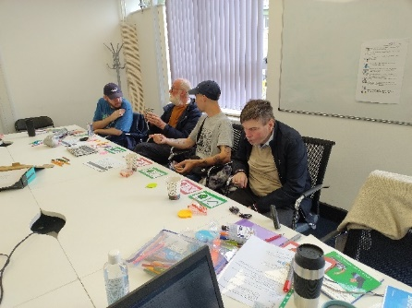  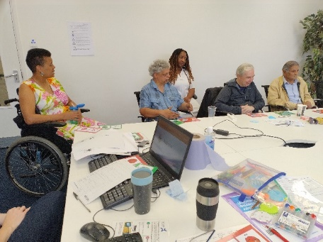 | There were 10 Residents, 1 Carer, 1 Support Worker at the meeting.  We will not read out the names on this video. Members of the group have the full minutes.  We also had 2 staff from VoiceAbility Connections:  Trish and Nicki  Melissa McAuliffe (Newham Commissioner) and Honey Sarfo (Newham Co-Production) ran the meeting.
At the end of the minutes, there is a Jargon Buster. Words that have a * next to them will be explained in the Jargon Buster.
These are words that we think need to be explained.
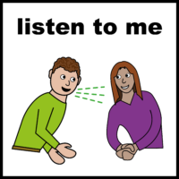 | We talked about being Heard and valued.
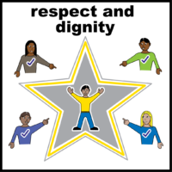 | We talked about the importance of being treated with dignity and respect.
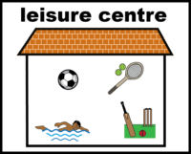 | We think that clubs such as gyms, social groups and some cinemas were respectful when there were Disability groups.
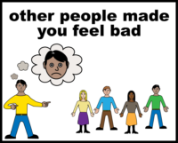 | There were places in the community where people felt discriminated* against.
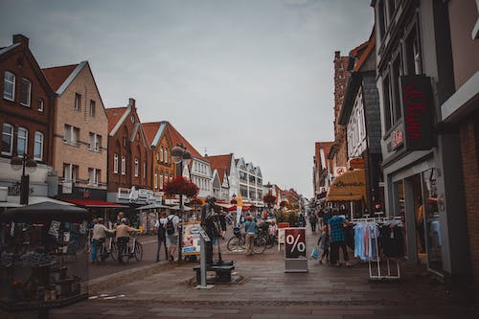 | These were places used by everyone such as:  Shops  Restaurants  And public transport.
 | Some places were only good when they had Learning Disability or Autism groups. They gave the gym as an example.
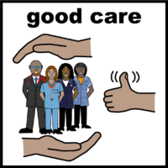 | It was also felt that Providers, the Police, the Council, Support Workers, and even some Social Workers and Advocates have a lack of respect and understanding.
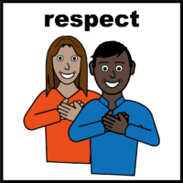 | We looked at what respect meant to people and how the lack of respect made people feel.  We though that respect meant:  - Be kind to each other and treat people how you would like to be treated.
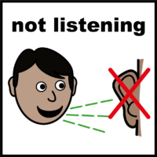 | We did not feel like we are treated like that.  We felt that people don’t listen; they don’t take the time to listen.  Some people are dismissive* and there is no respect for people with learning disabilities or Autism.
One man said that he likes to stay anonymous* when he is in the supermarket.

He does not want to be asked if he needs help.

He would like to do his shopping quickly and get out of the supermarket.

One woman said that Ping Pong in Westfield was not good.

She said that they don’t understand people and try to serve as many people as they can.

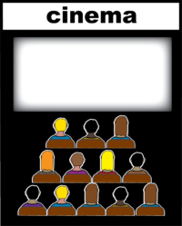 | One person said they would not go back to Stratford Picture House.  This was because the person behind the tills was screaming (when they visited in 2015).  They now go to other cinemas, even though it costs more.
 | The group also wanted to make the point that there are nice people who do understand us.
The group took a vote

7 people said that they are not shown respect by other people in the community.

3 said that they are shown respect in the community.

We talked about access to information and advice

People would like to receive information that is accessible.

 | People liked Easy read and Audio (information to listen to).
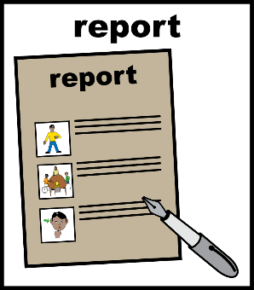 | The group took a vote on which Easy Read images they prefer:  6 people voted for Photo symbols  3 people voted for drawings (like Easy on the I)  The group said that they would be happy if both Photo symbols and drawings are used.
 | We had a Break
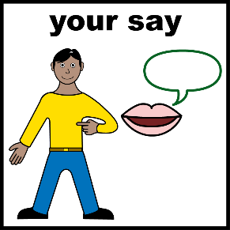 | We talked about how we can make our voices heard.
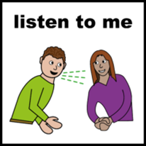 | We though that our voice was heard:  - If people listened to what we are saying  We thought that if people don’t listen, they think they know better than we do.
One person said that professionals* don’t take the time to listen.

They are always in a hurry and not as supportive as they should be.

We thought that time is a huge factor.

One person thought that they were not heard by the Police during a Safeguarding investigation.

They had an Advocate. They felt let down by the situation and did not feel they can rely on the Police.

Review Meeting  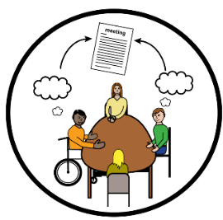 | They also said that they only see their Social Worker when they have a review.
We talked about being heard when we disagree.
Some of the questions were:
- What can you do if you disagree with the police?
- What do you do if you disagree with a professional?
- Can you make a complaint?

The group talked about who do you complain to, and will they actually listen?

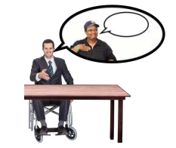 | We voted for the Co-Chairs of this Group and the Delivery Board.  Nathan Paul had the most votes. He chose to be the Co-Chair of the Resident Advisory Group.  Jade Sempare and Christopher Fuller tied for second. They agreed to share the role of Co-Chair for the Delivery Board.
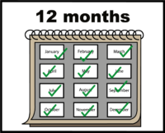 | Congratulations to the new Co-Chairs. This role will last for 1 year.
 | Neil Johnson will continue representing Newham People First at the Newham Co-Production Forum*.

Jargon Buster
Discriminated | This is when a person is treated unfairly or badly because they are part of a particular group.  In this meeting, people felt they were treated unfairly or badly because they had a Learning Disability.
Dismissive | This is when you treat someone like they are not important or not as valued.  You can be dismissive in the words you use or the way you behave.
Anonymous | In this meeting, the person used anonymous to mean that they did not want other people to notice them.
Newham Co-Production Forum | This is a meeting that talks about Health and Social Care issues that are important to the Community.  It has members of Community Groups, Councillors, Health staff, and Newham Council staff.
Professionals | This can include NHS / Health staff, Newham Council Staff and other people paid to work with us.

Icons in these minutes are from ‘Easy on the I’ (Image Bank - Learning Disability Service (learningdisabilityservice-leeds.nhs.uk)
Photos in these minutes are from Pexels (www.pexels.com and are royalty-free images)

