
LBN Adults Market Position Template
Commissioning Activity Area: | Residential and Nursing Care for Older People
Author: | Sarbjit Rai
Lead Commissioner : | Lydia Drummond
Date: | January 2017
Commissioning Summary And Key Actions:
The Council aims to support its residents to remain as independent in their own home, for as long possible; however we recognise that care homes provide an important service to those who can no longer live safely at home.

In Newham there are two Residential Care Homes and six dual-registered Residential and Nursing Care Homes for residents aged 65 and over – providing a total of 550 beds spaces. Placements are commissioned on needs and generally fall into 4 categories; Residential, Residential dementia, Nursing or Nursing dementia

In 2015/16 we had a total of 656 older people funded placements in a care home with the cohort ranging from 65 years old to 105 year olds and the average age of a person in the care homes being 85 year old.

We know that 313 of these were placements in Newham care homes making up 57% and the remaining 43% were placements out of the borough with other Providers across the country.

The Council’s financial spend in 2015/16 on the Newham Older People Care homes was £5,265,411 pa. The total spend for older people placements in 2015/16 was £9,104,516 pa.

In addition to the 313 Council commissioned placements, there were also 17 placements taken up by Newham fully health-funded care and 27 by self-funders and around 114 by other local authorities or CCGs.

In 2014/15 the average occupancy levels run at 94.5% and 92.5% in 2015/16, however when including the care homes with suspensions in 2015/16 the average occupancy rate was at 86.3%. The average occupancy national are at a rate of 90.1% for the entire independent market. This figure is also mirrored in the Greater London regions.

The Council predicts that the need for beds is going to increase over the coming years rising to approximately 705 by 2020, so compared to 2015/16 where we had 656 placements, we will be making an additional 49 placements. By 2025 we predict this will increase to 783 beds, an additional 127 placements from now to 2025. In total, this is a predicted growth of 19% in the next 9 years. The analysis is based on historical placement numbers mapped against future population growth figures.

The Council are also aware from referrals coming through to its Brokerage Team that there is an increase in the number of Individuals requiring specialist care and support in relation to Dementia; Palliative and End of Life Care (EoLC); Bariatric / Plus-Size care; and various Mental Health conditions - some presenting with challenging behaviour.

What Is The Identified Need/Demand In This Area?

Population
A key part of the analysis has been to understand the local market and how Newham currently compares with the national market. At present Newham does not reflect the national market. Namely Newham has fewer self- funders in 2015/16 there were approximately 27 (5.3%) self-funding individuals Whilst the situation in Greater London where 30% of the population were self-funders

By 2025 Newham’s residents aged 65 and over are predicted to grow to 31,600 (8.31% of the population as a whole). This is an additional 8,900 over 65 year olds, a 39% increase. At present people aged 65 and over represent 6.9% of the Newham’s population, which is low compared to the national average (17.83%).

Table 1 –Population source GLA
Age range | Population 2025 | Population 2030 | Population 2035 | Population 2040
0 -17 years | 89,100 | 91,300 | 90,500 | 90,200
18 - 64 years | 257,100 | 267,200 | 267,000 | 268,800
65 – 84 years | 28,100 | 33,600 | 38,600 | 42,700
85+ years | 3,500 | 3,900 | 4,900 | 6,100
Total | 380,000 | 398,500 | 415,200 | 429,600

Table 2 below illustrates total of placements in each category from 2008/09 to 2015/16. This is broken down into the 4 categories and shows how many total placements we had at the end of each financial year.

Table 2 Source: CareFirst Report (November 2016)
Total placements including breakdown on type of placement year on year
 | 2008/09 | 2009/10 | 2010/11* | 2011/12* | 2012/13* | 2013/14 | 2014/15 | 2015/16
Nursing | 239 | 226 | 205 | 200 | 208 | 182 | 175 | 161
Nursing Dementia | 84 | 96 | 102 | 91 | 94 | 105 | 111 | 119
Residential | 290 | 281 | 248 | 309 | 325 | 287 | 226 | 205
Residential Dementia | 67 | 76 | 95 | 106 | 90 | 114 | 160 | 171
Total Placements | 680 | 679 | 650 | 706 | 717 | 688 | 672 | 656
*Please note the years highlighted show an anomaly to the trend which has been put down to mass data re-load that may have resulted in some mis-coding. This does not impact the trend analysis.

As illustrated in Table 2, the significant changes over the last 8 year period:

- number of placements in residential dementia have increased by 155%
- there has also been a 42% increase in the number of nursing dementia placements
- nursing placements have fallen by 33%
- residential placements have fallen by 29%

As the number of individuals living in the borough with dementia is forecast to significantly increase from 1,521 in 2014/15 to 2,250 by 2031, it is anticipated the need for dementia placements will continue to grow. Currently, Newham has 159 dedicated dementia beds.

Table 3 Carefirst data
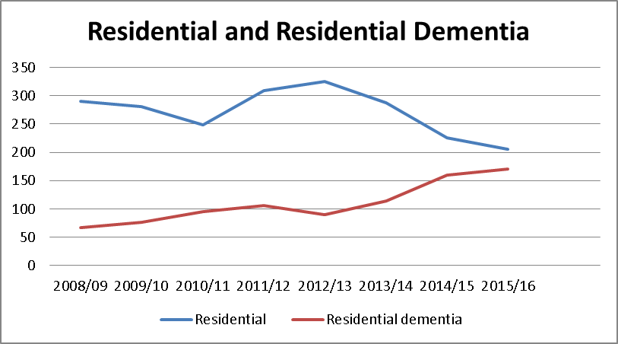

Table 4 Carefirst data
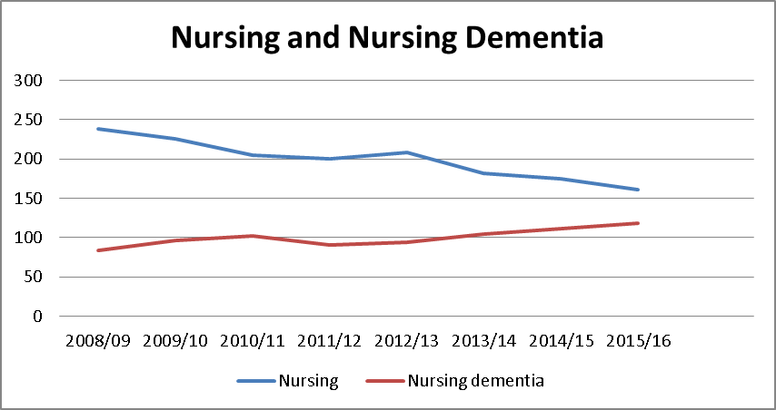

Table 3 and 4 highlight that there has been a steady decline in the number of placements for both non-dementia Residential and Nursing placements. This is likely to be a result of the Council’s drive towards resilience and supporting Individuals to remain in their own homes for as long as they are safe to do so through the use of Community Equipment and improved Community Nursing and Domiciliary Care. As such, Individuals have tended to move into a care home at a much older age in line with national and local policy to support individuals to remain independent and resilient for as long as possible, by which time, they have often developed Dementia and / or nursing needs.

Spend
The Council’s financial spend in 2015/16 on the Newham Older People Care homes was £5,265,411 pa. The total spend for older people placements in 2015/16 was £9,104,516 pa.

The Council sets a benchmark rate which is an annual ceiling rate for Care Home placements. The rate provided is based upon individual need, the financial climate and the reported financial position of each provider.

The 2016/17 benchmark rates are shown in the table 5 below:

Table 5
Benchmarks | Per Week
Residential | £475.12
Residential dementia | £540.84
Nursing | £671.99 *
Nursing dementia | £697.09 *

*(inclusive of Funded Nursing Care of £156.25)

If an individual chooses to live in an older people care home that costs more than the agreed rate, a top up by family member is required to cover the additional cost. For placements outside the borough, the Council abides by the benchmark rates set by host Authority.

Demand
We know that based on the previous number of placements from 2008 up to 2015; there has been an overall decline from 33 placements per 1000 people over 65 in 2008 to 28 placements per every 1000 person over 65 in 2015. This is a reduction of 5 people per 1000 people over 65.

Taking this into account and looking at the patterns of growth per each four types of placement and predicted population growth. We have undertaken some future predictive forecasting and highlight the 3 scenarios of predicted placement numbers by 2025 based on the last 8 years historical data.

Table 6 – Possible scenarios predicting future placement numbers
Scenario | Criteria | Predicted Number of placement by 2025
1 | While Non-dementia nursing placements showed a strong linear decline, and non- dementia residential placements, a strong correlation with the total number of dementia placements.  Scenario 1, is based on these trends and correlations an estimates that by FY 2025, if these trends continue, the non-dementia nursing budget will dwindle to 1/3 of the size it was in FY 2015 and dementia nursing placements could make up the bulk of nursing placements, as the total number of nursing placements continues to shrink.  Residential placements could be completely over run by residential dementia placements after 2025 if the total number of residential placements are expected to remain as stable as they were between 2008-2015.  This scenario also makes the assumption that life expectancy, healthy life expectancy and developments in health care will increase at the same rate seen between 2008 and 2015, but not any quicker. | 707
2 | Scenario 2, is exactly the same as scenario 1, except that instead of non-dementia residential placements decreasing in line with the total number of dementia placements, they decrease in a linear fashion. This would cause the need for around 200 extra residential placements to be funded by 2025; this is due to the compounding effect of a slower decrease in non-dementia residential placements and an increasing number of residential dementia placements . | 859
3 | Scenario 3, shows the number of placements which would be required by 2025 if there were no change in the rate of placement per head of 65+ population as observed in 2015.  This is not a likely scenario, but is there as a comparison to show what would happen if nothing changed other than 65+ population expansion as forecast by The Greater London Authority (GLA).  The most likely scenario could be said to be somewhere between scenario 1 and 2. | 905

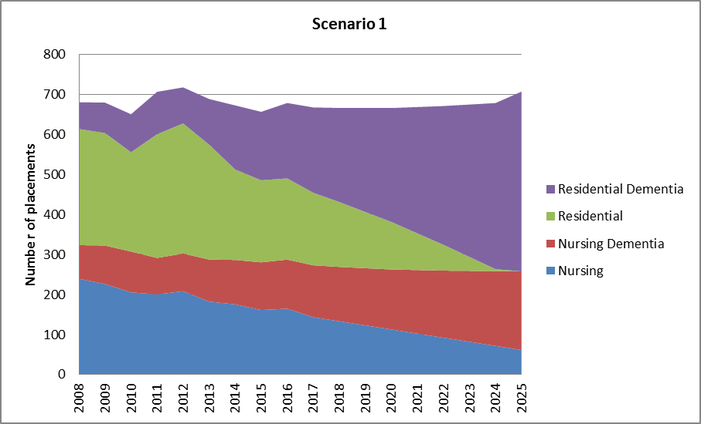
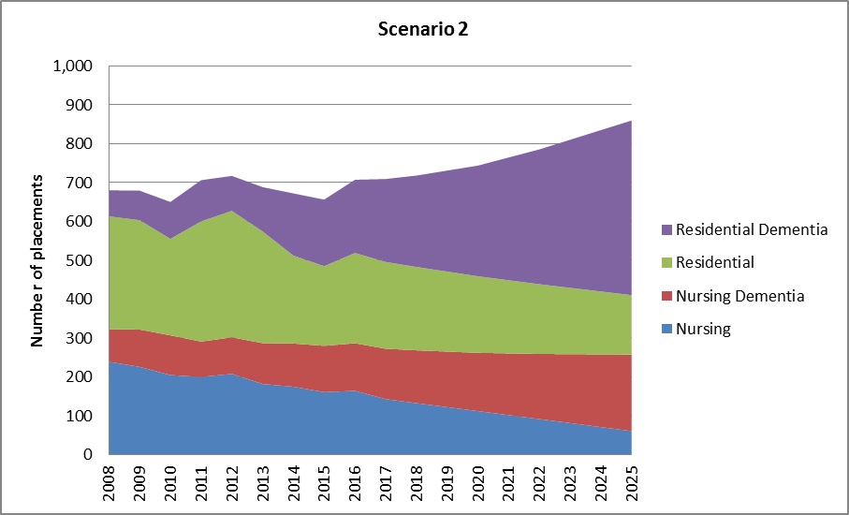
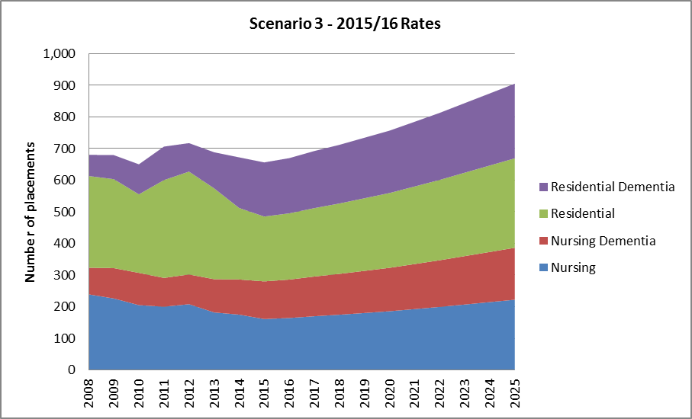

Therefore, as per table 6. if we take the likely predicted placements to be the average of scenario 1 and 2, this will be a total of 783 placements being made by 2025. Total increase from 656 placements to 783 placements is an estimated predicted growth in placements of 19% by 2025.

This demographic change is expected to lead to a need for increased bed numbers. However, the caveat to this is there are many variables such as Health Live Expectancy data, the impact of dementia and other policy changes that will impact the predicted increase.

Dementia
Dementia is one of the biggest health care challenges. In 2015 it was estimated that of 850,000 people with dementia in the UK, 72,000 were in London.

Table 7 – Dementia placement increase against population 2008 to 2015
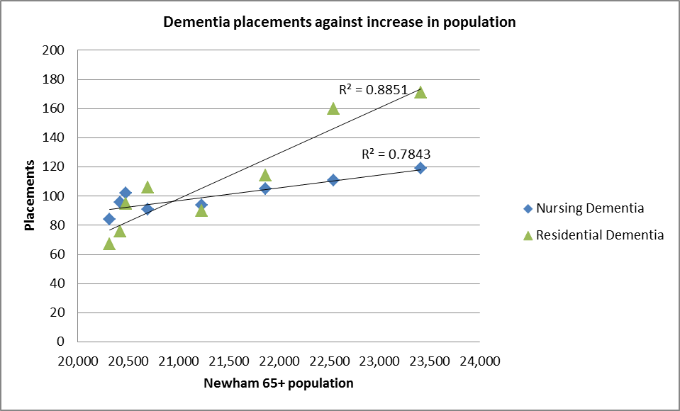

We know in Newham in August 2014, there were 1521 people with dementia in Newham, including 540 people with undiagnosed dementia. By 2031, this rate is expected to rise by 50% to 2,250. Furthermore, the number of older people presenting with dementia-related social care needs has increased in the Borough over recent years and is projected to further rise by 50% to 2025. Currently in Newham there are 159 dedicated dementia beds.

Is There A LBN Or Jointly Commissioned Service Currently In Place? |  | Yes
Current Contractual Status And Performance

In line with The Care Act 2014, residents whose care and support needs have been assessed to be best met in a Care Home have the choice (with support from their family and Health and Social Care practitioners) to choose which Care Home they would like to live in - providing the Home is able to meet their needs.

To ensure that each Care Home, which a resident chooses to live in, meets the Council’s requirements and expectations, the Adult Social Care Contracts Team has developed a Pre-Placement Contract (with pre-agreed Terms and Conditions and Specification), which they ask each Provider (located within and outside of the borough) to agree. Placements are then purchased on a spot basis via an Individual Service Agreement (under the terms of the Contract).

In 2014/15, the Contracts Team introduced an Integrated Quality Assessment Framework (i-QAF) in conjunction with the Newham CCG and care providers. The i-QAF is designed to collate information across a number of domains including clinical effectiveness, care planning, safety, workforce, leadership and management to monitor and measure quality and performance. It is reviewed on a regular basis and updated in light of legislative changes and the requirements of NICE, the CQC and Commissioners.

The implementation of the i-QAF has led to improvements in care homes and pathways into the service, for example:
- Five out of the eight Newham-based Homes ( 278 beds out of the 548 beds) have seen their CQC ratings improve (close to the national average of 60% of Care Homes being rated ‘good’);
- reduction in A & E admissions;
- reduction in ambulance call outs from 589 in 2014/15 to 473 in 2015/16;
- increased number of Advanced Care Plans in place for Individuals approaching the end of their life;
- introduction of new targeted training programmes being delivered by CCG and LBN
- increases number of Life histories being recorded by care homes

Care homes have engaged fully in the process and work closely with the Newham Contracts Team to ensure they meet all service improvement plans. This has seen four homes’ CQC ratings improve in the last 2 years:

Table 8 CQC ratings of care homes based on latest inspection as at Jan 2017
Name of Home | CQC Rating Published | Safe | Effective | Responsive | Well led | Caring |  | Overall Rating
Manor Farm | 14/08/2015 | Good | Good | Good | Requires improve. | Good |  | Good
Westgate House | 04/10/2016 | Inadequate | Requires improve. | Requires improve. | Requires improve. | Good |  | Requires improve.
Bakers Court | 01/11/2016 | Good | Good | Good | Good | Good |  | Good
Mornington Hall | 18/05/2016 | Requires improve. | Good | Requires improve. | Good | Good |  | Requires improve.
Summerdale Court Care | 08/06/2016 | Requires improve | Requires improve. | Good | Requires improve. | Requires improve |  | Requires improve.
Folkestone Nursing | 21/07/2016 | Requires improve | Requires improve. | Good | Requires improve. | Good |  | Requires improve.
Floron Care Home | Jan 2017 | Good | Good | Good | Good | Good |  | Good
Haven Lodge | 29/04/2016 | Good | Good | Good | Good | Good |  | Good

In 2015/16, Adults Social Care introduced a Bonus Payment Programme to incentivise the eight in borough homes to improve (and evidence that they have improved) the quality of care and support they provide. Each care home was scored on six categories (CQC rating; Contract-monitoring; individual satisfaction, i-QAF; financial stability and investment; staff training and supervision; and policies and procedures). For care homes that score 70%+, they receive an additional payment on a quarterly basis of 1% of the amount the Council has spent with them during the quarter - a score of 80% and 90%+, will see a bonus of 3 and 5% respectively.

Each payment award is reinvested into the Home for the benefit of individuals (e.g. individual activity / trip, redecoration, staff training, etc).

A critical part of quality monitoring process is obtaining individual feedback as such, the Contracts Team have trained Co-Production representatives to gather the views of individuals about the quality of care and support they are receiving. In 2016/17, individual satisfaction has been included in the Bonus Payment Programme.

How Well Does The Current Provision Meet The Identified Need

The Newham-based care homes are fully able to manage the four categories of care mentioned. However, the homes need to continue to adapt to the changing needs of the population and will need to remain focused on the needs of the local market.

The i-QAF has seen quality improvements in all areas of residential and nursing care by joint working with the CCG. Joint working with CCG and homes have encouraged the improvements to Dementia services; and better communication, in terms of understanding individual preference in relation to end of life care. However, more work is still required in these areas and the CCG and Council is supporting the care homes to train their staff to improve their understanding and good practice in these areas.

In 2015, the CCG conducted a nursing home review and looked at the finding from the i-QAF. From the nursing review, it highlighted a de-skilling of nurses and as well as other areas that required the care homes to focus on developing. Each nursing home was consulted and training programmes have been put in place by the Council and CCG that will support the care homes in making the necessary improvements.

There are new emerging needs such as bariatric care, we are starting to get referrals for individual over 65 years and over 20 stones. The care homes have struggled to accommodate for individuals of this size due to room sizes and specialist equipment.

We are also seeing a rise in older people with complex conditions such as learning disability, forensic or mental health conditions. Currently care homes are not able to meet the needs of those highlighted as staff have not trained to manage these needs. More work is planned with commissioners developing this area with the care home market.

MARKET STATUS AND DEVELOPMENT

Current Provider Market

The care homes based in Newham range from small converted domestic properties run by independent businesses, to larger purpose built home run by corporate national firms. National data from Laing and Buisson indicate Newham have a higher proportion of homes owned by key national organisations than the national market.

Table 9 Market Share of beds in Newham
Care Home Name | Number of beds | % of Newham Market
Manor Farm Care Home | 81 | 14.7
Westgate House Nursing Home | 80 | 14.5
Bakers Court Nursing Home | 78 | 14.1
Mornington Hall Care Home | 120 | 21.8
Summerdale Court Care Home | 116 | 21.0
Folkestone Nursing Home | 45 | 8.2
Haven Lodge | 14 | 2.5
Floron Care Home | 16 | 3.2
Total | 550 | 100
In

The demand for all types of placements in the market will outstrip supply based on predicted growth figures.

Gaps In Current Provision / Desired Market

Care Homes need to improve the quality of the care and support provided to Individuals:

- with Dementia by improving their knowledge of the condition; how care and support is provided in line with NICE guidelines and best-practice identified in this area by leading Dementia organisations (e.g. the Alzheimer’s Society);

- approaching the end of life in order to facilitate a compassionate and dignified death within the Home; and reduce the number of hospital admissions in the last days of life. This is to be achieved by providing training to the staff to have honest and difficult End of Life (EoL) care discussions. The homes should ensure that the plans are appropriately recorded, communicated to other stakeholders who are caring for the resident. The focus should be to adhered to (where possible); and by training staff to better-manage the individual and support their families and friends in the last few days of life (e.g. relief from pain and distressing symptoms, and provide support to individual and their families and friends);

The Council has also seen an increase in the number of Individuals who require Care Home provision who:

- are plus-size /Bariatric- individuals –requiring a larger bed and moving equipment; sometimes requiring 2:1 person support;

- korskoffs syndrome – where symptoms include; memory loss, etc.;

- Challenging behaviour (e.g. aggression, inappropriate sexualised behaviour, history of committing sexual offences, lack of awareness of danger, self-harm, etc) where individuals require staff that are trained in dealing with challenging conditions to manage these needs to provide a safe care environment.

Opportunities / Limitations In Supporting Future Market Development

Business Development Opportunities to consider:

- Stepdown beds are short-stay beds in a residential or nursing setting for people who no longer require acute medical services provided by hospital but are not yet able to go home.

- Stepdown beds provide an opportunity for people to recover in a more homely environment if going home is not a suitable option. This is usually whilst awaiting re-adaptions at home or awaiting Continuing Health Care (CHC) assessments, also gives people time to consider their options for meeting their longer term needs.

- The Council currently have 13 stepdown beds but there is an increasing demand for this type of facility.

- The development of specialist bariatric care services to accommodate and care for people over 20 stones. The Council has seen an increase in obese older people requiring residential or nursing care.

- The demand for both residential and nursing dementia care has steadily increased.

- Specialist staff trained to support older people with mental health or learning disabilities needs that are displayed through challenging behaviour

Commissioner intentions for future of the service
The Council intend to review the current Pre-Placement Contract with a view to:

- simplify and hone the main Service outcomes, outputs

- improve quality through refining Key Performance Indicators;

- improve the variety and quality of recreational activities available for Individuals, including access to local community-based provision;

- improve the care and support provided to Individuals with Dementia;

- improve the respite offer for Individuals who require a short-stay in a Home;

- improve the care and support provided to Individuals who are approaching the end of their life, in order to facilitate a compassionate and dignified death at the Home (where this is their preferred place of death);

- work in partnership with the market to improve the capacity of Homes to support individuals presenting with a variety of complex Health and Social Care needs and challenging behaviour.

SHORT, MEDIUM AND LONG TERM ACTION PLAN TO MOVE TOWARDS DESIRED MARKET STATUS AND MEET COMMISSIONING INTENTIONS

 | Key Actions To Be Taken
Short Term (6 months) | - continue to support homes to improve quality of care and improve their CQC rating to be in line with the national standard;  - consult with the homes to review their current provision in relation to the specialised needs identified and potentially develop a new framework.
Medium Term (1 year) | - support the implementation of the Nursing Care Review Action Plan;  - agree a clear strategy on Older People care. This would include the review of the contractual arrangements in place with the care homes;  End of Life Care:  - Introduce a universal Advanced Care Plan that is populated and can be viewed by all relevant stakeholders, including Care Homes, as appropriate;  - increase Care Home knowledge and use of various EoLC services to support Individuals approaching the end of their life to die at the care home;  - work in partnership with CCG to provide training to enable homes to partake in honest and difficult EoLC conversations with individuals who are approaching the end of their life; and provide appropriate care and support, particularly during their last days of life - supporting them to die at the Home.
Long Term (1-3 years) | - review the Service and make improvements identified as good-practice from the Enhanced Health in Care Home vanguards;  - explore opportunities to work more closely with other Local Authorities around a shared outcomes framework and increase the numbers of placements currently available within East London Region.

Care first data sets
Carefirst data sets
Care first data sets
Care first data sets
I-QAF data Q3 2016/17
I-QAF data set 2014/15 and 2015/16
Laing Buisson June 2016
Regression analysis on Carefirst data
Laing 2015
GLA
Newham Joint Dementia Strategy 2015-2018
Newham Joint Dementia Strategy 2015-2018
Care first data sets
Care first data sets
Newham Joint Dementia Strategy 2015-2018
Newham Joint Dementia Strategy 2015-2018
Newham Joint Dementia Strategy 2015-2018
I-QAF data
i-qaf data

