

Market Position Statement – Strategic Summary Document

Contents
Page
What is a Market Position Statement? LBN Approach 2.
Key messages 3.
Current and future need and demand information for Newham 4.
Expenditure on Adult Social Care Services 5-6.
Adult Social Care Users by Ward 2016 and breakdown of client groups 7.
Service gaps and commissioning intentions 8-13.

About the Market Position Statement
The purpose of a Market Position Statement (MPS) is to form the basis of a dialogue between Newham Council Adult Social Care commissioners and providers of social care services. These documents are intended to give providers information about where we are currently and what we would like to see develop in the future to meet the needs of people who have adult social care support needs.
LBN Approach
In 2012, the Department of Health supported most Local Authorities to undertake a MPS. Subsequently the Care Act statutory guidance named them as an appropriate tool for Authorities to meet their statutory duties around market shaping.
For most authorities, Market Position Statements are issued as a single document, which are updated as a whole every two years. LBN’s vision is for its MPS is to be a dynamic suite of documents, with different areas of the commissioning landscape having their own dedicated MPS.
This approach will ensure a degree of continuity, as all commissioning areas will complete a common template that will covering key information, including:
- needs analysis
- analysis of current provider market
- short and long term commissioning intentions and action plans

This approach will also make the content more meaningful, since the different commissioning areas in which ASC operates represents very different markets and customer bases with potentially different commissioning approaches. These documents will be updated as commissioning intentions evolve, without the need to wait for the next iteration of a larger single document.
By sharing this information, and by signalling our intention to update it as a dynamic document, LBN Adult Social Care hopes to build on the established partnership we already have with providers, working together to support our customers to receive appropriate and high quality services.
Once a year a strategic summary document will be published, pulling together key findings and actions from across the range of services commissioned by LBN Adult Social Care. This document is the first iteration of this strategic document. The overall vision of LBN Adult Social Care is to ensure:
Increased choice and control for individuals
Individuals have increased independence
People are included and connected in the community
Services offer quality and value for money
Services meet the needs of individuals they are supporting
People with social care needs are safe

In order to provide more joined up services for customers and patients, LBN and Newham Clinical Commissioning Group (NCCG) are increasingly commissioning services in partnership. At the heart of this process is a drive towards a shared outcomes framework between the health and care commissioners, which will help bring greater clarity and stability to the provider market through consistency. CCG colleagues have been engaged in the production and agreement of the individual Market Position Statements.
Key Findings of the Market Position Statement, 2016-17
The impact of the rising population in Newham along with increasingly constrained resources has meant that there is has been increased pressure on all of the services that Adult Social Care delivers, particularly around the complexity of care needs for some individuals.

The most significant policy change to ASC in recent years has been introduction of the Care Act in 2015 The principles of the act are to be welcomed, and have helped to bring clarity to the outcomes that are set by commissioners as part of contracts with providers.

However, in the context of increasingly constrained resources the Act poses a considerable challenge for both commissioners and providers of care. We are proud of our positive partnership with providers which has helped us to develop strong and flexible commissioning relationships to address identified commissioning gaps in recent years. As described in the individual homecare MPS, an identified shortage of suitable homecare provision has been addressed through our new Independent Living Support Services framework which sees us work with 17 providers of varying sizes, and we have worked in partnership with the residential home sector to improve links with other parts of the health and care system.

We recognise that the best outcomes for customers can often be generated by having an array of providers to choose from, and to continue to support increased personalisation of services, we wish to see a varied, flexible and sustainable social care market develop in Newham over the coming years, in areas where personalised care is required (e.g. . day opportunities, homecare). We also recognise that there are risks to providers in the current economic context. To try and mitigate this as far as possible, LBN will commit to be open and up-front about commissioner intentions, hosting market engagement days with potential providers and having an open dialogue. During the recent commissioning of the independent living support services, we held very a productive dialogue with providers, resulting in a successful large-scale procurement and framework contract.

Alongside this, a need for increased stability for both providers and commissioners must be taken into account through the commissioning approaches taken. The context of reduced funding means that commissioning/contracting arrangements need to provide adequate assurance for providers around price of service. Similarly, commissioners need suitable contracts arrangements in place, in order to be sure that they will have reassurance over delivery, as well as greater confidence over expenditure levels. This balance is demonstrated across a range of the individual Market Position Statements for community based services, where there is often a rationale for having a single provider undertake a single service

One of the ambitions of a number of the services is to seek opportunities for collaboration across different boroughs, particularly joint commissioning. This would mean that there would be a more joined-up approach and would result in efficiencies through economies of scale. An example of this in action is the pan-Sexual Health procurement partner for notification, self sampling and web based services to be launched in 2017. The sexual health service is addressing this problem by LBN commissioners leading the development of a pan-London framework. Through this LBN participation in the London Sexual Health Transformation Programme (LSHTP) will be sought, and the scale of the procurement will bring security to providers.

The approach we have taken to this market position statement has been to focus on individual care markets. In relation to our last Market Position Statement, we have identified some new gaps as well as continued gaps in the area of accommodation for people with complex needs and challenging behaviour. Our individual MPS documents, hosted on the LBN Provider Zone (available here)- set out action plans to address these gaps, but we welcome input from providers on whether these are the right approaches.
Headline Needs analysis
The population in Newham has been rising rapidly in recent years, and although the trend appears to have slowed slightly in the last two years, that rate of growth is expected to increase again in the coming years.
Year | Population size | % rise | Average annual rise
2011 | 308,000 |  | N/A
2013 | 328,500 | 6.7 % | 3.4 %
2016 | 338,600 | 3.1% | 1.0 %
2025 | 387,700 | 14.5% | 1.9 %
(Source: LBN Strategic Commissioning)
Growth between 2016 and 2025 represents an increase of 14.5% - a significant change to the overall demographic. During the same period, this trend is more acute for people who are more likely to be customers of Adult Social Care. For those aged 65 to 79 their population is set to rise from 17,800 to 24,600, a rise of 38.2% and for those over the age of 80 their population is set to rise from 5,400 to 6,700, a rise of 24.1%. These changes are highly likely to put pressure on Adult Social Care in terms of an increase in demand for services.
Using nationally available projection tools, it is possible to plot the expected trends for individuals with varying types of need. Whilst useful for understanding possible levels of demand, specific locally based analysis must be regularly undertaken for each need area to be viewed alongside this data. Local demand will always fluctuate depending on local issues (e.g. ethnicity-based demographic), and not all people who have a certain condition will seek or be eligible for adult social care assistance.
Nationally available trend data is shown below for the areas of Mental Health disorders, Older People, Dementia and Learning Disability.
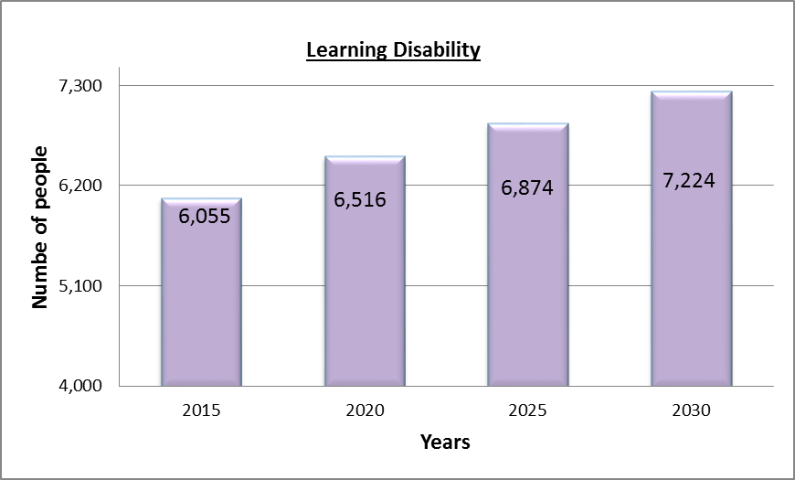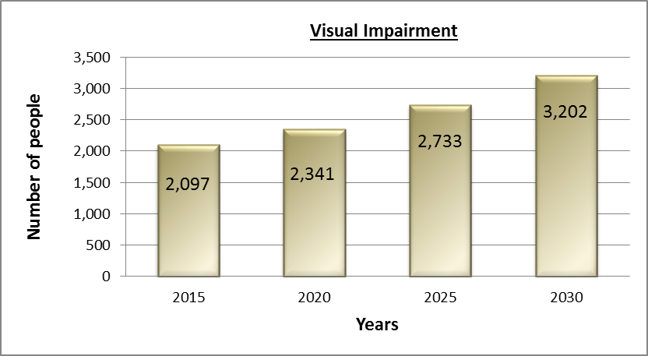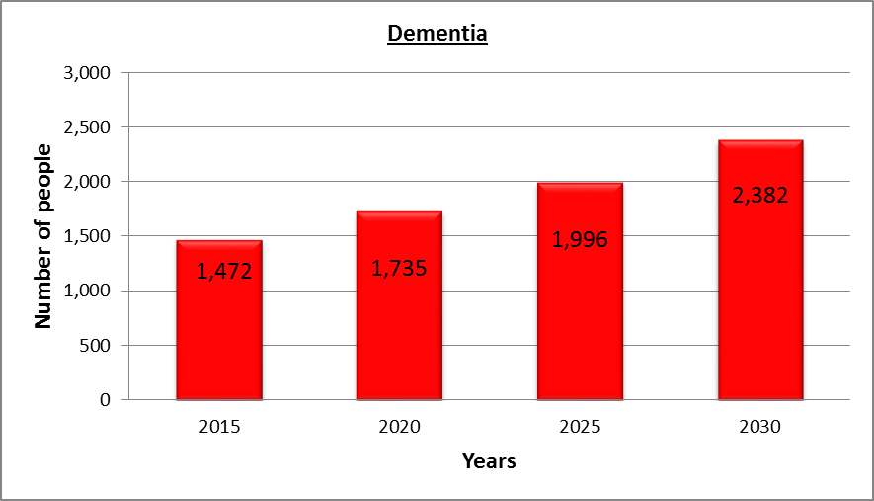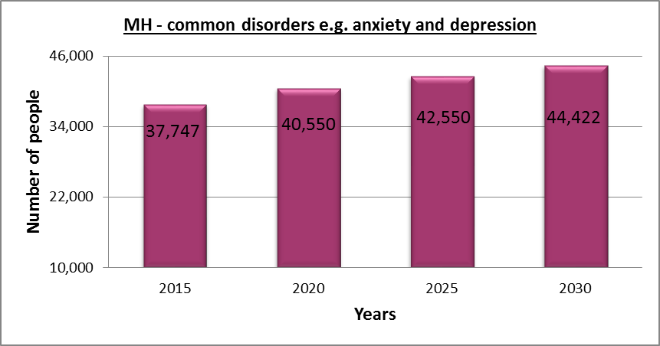
(Source, POPPI and PANSI, Institute of Public Care)

Expenditure on ASC Services
ASC in Newham commissions services for people with the following range of needs
- People with learning disabilities
- People with physical/sensory impairments
- Older people (living at home or in care settings)
- People living with dementia
- People with mental health issues
- People with a Substance Misuse – related need
- Population-wide programmes focussed on public health

In 2016/2017 expenditure on care services for adults in Newham (excluding supporting people and equipment and adaptions) accounted for over £67 million. The following tables set out the level of total expenditure on Adult Social Care services over recent years, broken down by spend on different types of service. The figures reflect a picture of increased demand in recent years, translating into a trend of increased expenditure.
 | 2013/14 (£000) | 2014/15 (£000) | 2015/16 (£000) | 2016/17 (£000)
Physical Support 18-64 | 7,429 | 7320 | 8339 | 8943
Sensory Support 18-64 | 7,429 | 363 | 417 | 398
Memory and Cognition 18-64 | 7,429 | 245 | 472 | 418
Learning Disability 18-64 | 20,516 | 19,795 | 19,583 | 20,519
Mental Health 18-64 | 6,983 | 6,533 | 6,341 | 6,268
Other 18-64 | 223 | 330 | 350 | 254
Older People 65+ | 26,293 | 26,600 | 28,093 | 29,276
Equipment and Telecare | 1,573 | 1,202 | 1,919 | 1,799
Total | 63,017 | 62,388 | 65,514 | 67,875

Care Type | 2016/17 Expenditure (£000) | % of total spend | % of total spend at previous MPS | % Change
Equipment and Telecare | 1,799 | 3% | 3% | 0%
Day Opportunities | 6,329 | 9% | 11% | -2%
Individual Budgets | 12,905 | 19% | 16% | +3%
Home Care | 13,178 | 19% | 19% | 0%
Supported Living | 11,472 | 17% | 12% | +5%
Nursing Care | 6,390 | 9% | 9% | 0%
Residential Care | 15,802 | 24% | 30% | -6%
Total | 67,875 | 100%
(Source: LBN Strategic Commissioning Team analysis)
Of the money spent on adult social care, around is 51% is spent directly on accommodation-based placements with providers, representing the fact that this area is the highest cost service offered by ASC. As a proportion of the total budget, this has stayed relatively consistent over the past few years, but since 2013/14 there has been a significant swing from expenditure on residential care to supported and other accommodation types (4%) and day care and home care to individual budgets (4%).
This is in line with the personalisation agenda, and reflects considered approach taken by social workers and commissioners to promote individuals to be supported to live in the least restrictive environment that will meet their needs. We anticipate this trend to continue into the future, with spend on equipment expected to increase as an overall percentage of the budget. Suitable equipment can be a key factor in helping people to maintain their independence in their own home, and the complexity of the equipment available on the market is developing at pace.
When compared to other London boroughs, Newham Council procures residential and nursing care for lower costs than other boroughs in London. The council has not been a provider of residential care since 2011/12 and does not intend to be a provider of care in the future. It is in the process of outsourcing or spinning out current services to become social enterprises or businesses independent of the council.

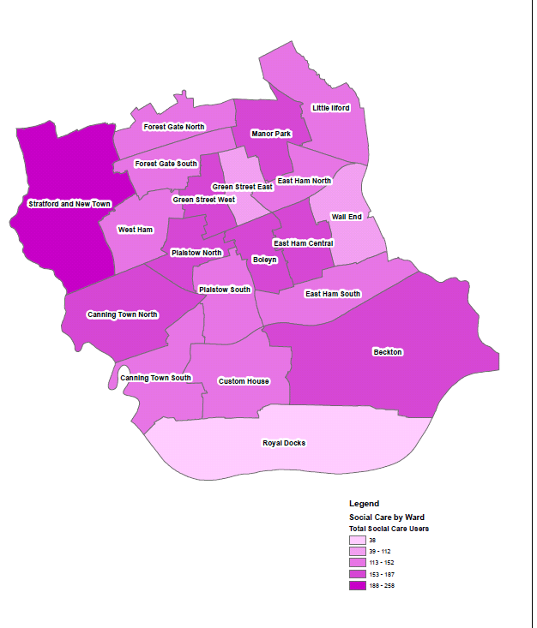
Adult Social Care Users by Ward 2016-17

This image indicates that the areas with the highest number of social care users by ward are Stratford and New Town, Beckton, Boleyn, West Ham Central, Plaistow North, Green Street West, Manor Park and Canning town North.
There have been no significant changes in relation to the equivalent findings for the 2014 MPS. The number of social care users in Forest Gate, Manor Park and East Ham has gone down slightly, whilst in Stratford the figure has gone up.

Summary of Identified Market Service Gaps and Commissioning Intentions
The following section sets out the headline findings of the individual Market Position Statements. Further detail can be found in the full documents located at the Provider Zone.
Service | Identified Gap and Action
Advocacy | The requirement on Local Authorities changed after the introduction of the Care Act, and with the evolution of the Deprivation of Liberty case law. LBN analysis of the existing contracted service showed that the volumes of advocacy contracted for different types of service did not match the level of demand that has evolved over the life of the contract. In particular, demand increased for the Independent Mental Capacity Advocacy service.  To fulfil this service gap, a commissioning process was undertaken in 2016 to identify a single provider to deliver all statutory services under a new delivery model, with new performance measures and funding mechanisms. This contract commenced in autumn 2016, and is now meeting demand. A summary of the different service strands and further detail is set out in the Advocacy MPS.
Carers | There are an estimated 24,555 informal carers in the borough of which fewer than 6,000 are known to health and social care services. Currently LBN and NCCG currently commission a joint community support service model with a single provider which performs well but it predominantly responds to people who come forward. There is a gap between the total number of carers in the borough and those known to services. More needs to be done in terms of outreach to carers to raise the exposure of the service and to reduce the gap between the total number of carers in the borough and those known to services.  The re-commissioning of the service will seek to address this gap through an exploration of the best model of delivery (e.g. small or large provider preference) and exploration of joint commissioning across services to provide added value and greater security to providers.
Domiciliary Care | The former Independent Living Support Services Framework (ILSS) agreement was commissioned in 2012. It originally comprised of 11 contracted providers, however this reduced over the lifetime of the contract which resulted in the increased use of “spot” providers to sufficiently meet current demand. On recommissioning the service, there was a requirement to reduce the number of spot-purchase packages to ensure that all Suppliers were delivering to an equitable standard of cost and quality. To ensure this, the council undertook a major re-procurement exercise in 2015-16 to increase the capacity on the Framework. The new framework places an emphasis on Providers ability to provide Care and Support for individuals with specialist needs - with a particular focus on dementia.  Following mobilisation to the new contract, capacity is being monitored continuously, to ensure purchase is exclusively from the framework as far as possible. In recognition of the need to spot purchase on an extra-ordinary basis only, the commissioner and contracts officers will undertake work to standardise requirements of spot-purchase providers, ensuring equal opportunity to providers not on the current framework.
Stroke Community Support | As part of a commissioning review of the service in 2016, it was identified that there was a gap around earlier stages of prevention of stroke. The existing service model only catered to customers who had already had a stroke. As a result, commissioners worked with health commissioners, providers and customers to update the specification and budget level to reflect a requirement for the service to extend into primary prevention as part of an aligned pathway with clinically commissioned services.  The service was re-tendered for a two year period in 2016. One previous gap that was identified through the consultation to stroke survivors was that support, in terms of information, advice and guidance, tends to cease after 12 months post stroke. As such, the new contract means the Provider facilitates two peer support groups for stroke survivors on a quarterly basis to provide this support based upon themes identified via the attendees of these groups (e.g. beneficial exercises, medication review, healthy lifestyles, etc). Another gap is in relation to formal six-month reviews of stroke survivors. The CCG are reviewing the Community Neurology and Stroke Rehabilitation Service. The review and redesign of this service will impact on the Service that LBN procures in the future. In late 2017, the council’s stroke support service is due to be re-commissioned.
Stop Smoking Service | Data from 2015/16 suggests that the borough is not meeting the National Institute for Health and Care Excellence (NICE) recommended targets on both number of smoking quit attempts and successful 4 week quits. The 15/16 quit rate was 30% (below NICE recommended thresholds). This however hides the variance in performance of current providers.  To address this gap a new service model that is focussed on Pharmacy-only will be undertaken. This will ensure that only the best quality of service is on offer to residents and that council funding is focused on the most cost effective interventions.
Sexual Health | Changing population demographics, increasing service demand, high levels of sexual health inequalities and year on year fall in central government investment means the current provider market place and service models are unsustainable for the following reasons:  - Limited promotion and access to sexual health services particularly in GP and pharmacy settings.  - Lack of mixed skilled nursing capacity within primary care trained to implement Long Acting Reversible Contraception (LARC)  - Lack of primary care subcontracting arrangements to deliver sexual health services  - A single and streamlined point of access for complex and specialist sexual health clinics (GUM) across East London boroughs.  - Limited use of innovative and technology based solutions to explore delivering sexual health services remotely i.e. home testing kits, telephone consultation and assessments.  To address these gaps, LBN commissioners are leading the development of a pan-London framework to procure partner notification, self sampling and web based services. Pan-London membership provides opportunities to procure areas of mutual interest across London boroughs. This approach will bring clarity and stability to the provider market.  To improve access and partner notification LBN will work collaboratively across London and procure a web-based system offering timely access to sexual health services and joined-up partner notification.  LBN participation in the London Sexual Health Transformation Programme (LSHTP). This will involve pan-London procurement for a web based “front end” portal and joined up partner notification provision.
HealthWatch | The market for Healthwatch providers has been historically small nationwide, and there has been a gap in the market for providers who have the resources and local intelligence to support multiple communities with diverse needs and barriers to accessing mainstream services. In 2016, LBN also identified a gap in their current commissioning model in terms of links with other NHS focussed commissioned services such as the NHS Complaints Advocacy service.  To try and meet the gaps in 2016, LBN have commissioned a provider to manage the a merged contract for Healthwatch and NHS Complaints Advocacy up to 4 years. The increased value of the overall contract was intended to be more attractive to providers. Commissioners will continue to explore the possibility of joint commissioning these services with neighbouring boroughs in the longer term to provide additional stability to the market.
Self-Directed Support Service | Commissioning analysis has highlighted a need to increase choice of providers in this area, and – in particular to ensure an up-to date service specification for Support Service, Payroll and Managed Account Service is developed. A new Framework Agreement for a Payroll Service will place an emphasis on transparency of payroll and cost and quality of service provided, ensuring a smooth journey for customers.  During 2017 commissioners will procure for a new payroll service, and work with the provider market to identify and agree commissioning intentions for IAG and Direct Payment Support Services. This will include developing a plan to connect customers to wider resources available in the community and extending its scope to deliver proactive health and wellbeing resources.  - Mapping of service requirement for Support Service (Information, Advice & Guidance), Payroll and Third Party Managed Account Service relating to Direct Payments;  - Development of procurement documents; and  - Implement the new Framework Agreement for a Payroll Service.
LD and Autism Services | There is insufficient supply of appropriate and timely support services for people with LD, especially accommodation for people with complex needs and challenging behaviour (in particular those leaving Assessment and Treatment Units (ATUs). LBN commissioners are aiming to deliver services In line with NHS England Housing Guidance, “Building the Right Home” however, providing high quality specialist accommodation locally to reduce such ATU placements is significantly constrained by a shortage of affordable sites. Commissioners are working in partnership with providers to deliver the right support,  LBN Commissioners are looking to develop a framework of specialist providers who can deliver supported living care and accommodation to those individuals who are part of the Transforming Care Programme cohort; those with learning disabilities and/or autism who have behaviour that challenges, who are/or at risk of being placed in an assessment and treatment unit. This will be pursued either a Newham project, or a joint project with inner or outer East London partners. This will be discussed further with providers once the structure has been determined.  A specific LD and Autism JSNA will be produced in 2017, followed by the development of a Joint Commissioning Strategy for people with Learning Disabilities, and a separate Autism Strategy.
Employment Support | LBN ASC currently provides a dedicated employment support team within LBN Workplace. This team provides dedicated employment support to people with care and support needs, and their carers.  Commissioners have identified that dedicated day opportunities that are commissioned on behalf of the council are not aligned with the Support to Employment Team (SET) or each other. Over 60 people are currently spending their Direct Payment/Individual Budgets to purchase employment support from other employment provider organisations but there has been insufficient evidence of job outcomes over the past 4 years. The commissioner intends to initiate discussions/work with all other employment provider organisations to look at ways of improving their services to be more focused on the employment needs of people to enable them to achieve stated employment outcomes.  Additional employment support services targeting those in work would be also beneficial, particularly to those showing early signs of work-stress or mental health problems. Providing support while in employment might prevent the problem escalating and reduce the need for psychological intervention.  The mental health employment service aims to become fully Individual Placement & Support (IPS) complaint within three years, following the eight key principles of IPS delivery. This includes working jointly with mental health treatment services. Employment specialists and clinical teams sharing information such as medication side effects and symptoms, as well as developing ideas together to help clients improve their functional recovery.
Supported Housing for Older People and Physical Disabilities | LBN Currently has eight Extra Care Housing schemes, and over 2000 units of sheltered housing – mostly provided by housing associations. One gap within the existing Extra Care Service provision is that there is a current lack of units against projected future demand due to a lack of Extra Care sites which currently meet the Housing LIN definition of having 24 hour care available on site. A re-modelling of existing services will be undertaken to bring the offer in line with the industry standard.  Existing providers have been engaged in the production of a headline extra care strategy which will be finalised in 2017.  Implementation will involve commissioning of new models of care at extra care sites including Cardamom and Hedgerow Court  Commissioners are also involved in planning for further extra-care facilities as part of the wider LBN regeneration and development programmes.  In conversation with existing providers LBN will undertake production of a wider Older People’s Accommodation Plan and Pathway. This will be developed in financial year 2017-18.
Residential and Nursing care | Commissioners work in partnership with the borough’s Care Homes in order to improve the quality of the care and support provided to Customers:  In recent years, the Council has also seen an increase in the number of Customers who require Care Home provision who:  - are plus-size/Bariatric- customers –requiring a larger bed and moving equipment; sometimes requiring 2:1 person support;  - learning disabilities  - those that present with challenging behaviour (e.g. aggression, inappropriate sexualised behaviour, history of committing sexual offences, lack of awareness of danger, self-harm, etc.). These Customers require staff that are trained in dealing with challenging mental health conditions to manage these needs to provide a safe care environment.  In the forthcoming year, LBN intend to review the content of the current service specification held with providers with a view to:  - simplify and hone the main Service outcomes, outputs and associated Key Performance Indicators;  - improve the variety and quality of recreational activities available for Customers, including access to local community-based provision;  - improve the care and support provided to Customers with Dementia;  - improve the respite offer  - improve the care and support provided to Customers who are approaching the end of their life.  LBN will also establish the a Care Home Forum to be led by commissioned Providers. The purpose of the Forum is to take forward partnership working and share information, with a particular focus on highlighting good working practice and identifying areas for improvement.
Mental Health Care and Accommodation | Though we cannot quantify the unmet need for preventative support, commissioners know from the large numbers of customers using accommodation-based services that there could be a benefit to funding services that intervene early to prevent tenancy and family breakdowns from occurring in the first place. Given the forecasts of mental illness in Newham, floating care and support services will need to be able to work with customers along the entire spectrum of need; from a wide range of backgrounds; providing rapid and intensive support to some customers and short-term, stabilising interventions to others.  A recent report from the National Audit Office (NAO) highlights the slow progress that’s been made across the country with introducing direct payments for customers with mental health needs. This trend is reflected in Newham, where only 7.7% of MH customers were receiving their social care package in the form of a direct payment as of 31/03/16. It is also the case that residents currently using mental health supported housing or other accommodation-based forms of care are not receiving their social care funding in the form of a direct payment. One possible reason for this is that the mental health care and accommodation market in Newham is not currently set up to facilitate the direct purchasing of services by customers. This means there may also be difficulties for individuals who would be required to purchase care and support services themselves to access the market (self-funders.). Commissioners have established key commissioning intentions that form the basis of a multi-year strategy for joint work with providers:  - Introduce cost regularisation guidelines for unit / placement costs, starting in summer 2017.  - Introduce individual service funds (ISFs) for accommodation-based mental health services by 2019/20. This will include:  - Realign spending to ensure mental health care and support services are delivered against all tiers of prevention by autumn 2018.  - Introduce new service models that will improve outcomes for customers. This will include:
NHS Health Checks | The quality of the service being delivered is an identified area of improvement. The commissioner intends to contract monitor providers increasingly on the quality of lifestyle assessment and referrals into services post-health check (i.e. stop smoking, substance misuse and weight management) to ensure value for money and improved outcomes for residents.

https://www.nao.org.uk/wp-content/uploads/2016/03/Personalised-commissioning-in-adult-social-care-update.pdf
Source: LBN Strategic Commissioning

